# AUTO-SCALING-GROUPS DAILY TASKS

**Project Implementation Summary**

| **Section** | **Details** |
| --- | --- |
| **Topic** | Deploy and Monitor a Highly Available Web Application using ALB, Target Groups, Auto Scaling Group, CloudWatch Metrics, VPC Flow Logs & ALB Access Logs in AWS |
| **Objective** | • Host Public & Private EC2 Web Servers in a VPC Architecture  • Configure an ALB to distribute traffic  • Implement Auto Scaling for traffic load response  • Enable ALB Access Logs to S3 and VPC Flow Logs for monitoring  • Track CPU Utilization & Apache Service health using CloudWatch Dashboards  • Perform load test to validate scaling behavior  **Prerequisites** |
|  | • AWS Account in us-east-1 Region  • VPC with Public & Private Subnets  • EC2 Instances (Amazon Linux 2023) with Apache installed  • S3 Bucket for ALB Access Logs  • IAM Role for VPC Flow Logs & CloudWatch publishing  • Target Group & Application Load Balancer  • Launch Template for Auto Scaling  • Security Groups allowing HTTP port 80 |
| **Errors Faced** | **Issue 1:** ALB Access Logs — “Access Denied for bucket”  **Issue 2:** Auto Scaling instances not connecting properly at first attempt  **Issue 3:** CloudWatch Custom Metric not showing |
| **Fixes Applied** | **Fix for Issue 1:** Updated S3 Bucket policy to allow log delivery by logdelivery.elb.amazonaws.com  **Fix for Issue 2:** Enabled ELB health checks in ASG configuration  **Fix for Issue 3:** Installed CloudWatch agent and configured IAM permissions + cron job for Apache monitoring |
| **Conclusion** | • Application Load Balancer successfully forwarded traffic to healthy EC2 targets  • CPU spikes triggered Auto Scaling — new EC2 launched and older ones terminated  • CloudWatch Dashboards successfully monitored CPU & Apache status  • ALB Access Logs stored in S3 & VPC flow logs captured in CloudWatch Logs  • Entire setup validated high availability, scalability & observability of AWS architecture |

1. Create one VPC in N. Virginia region.

**Logged into AWS Management Console**

* Region selected: **United States (N. Virginia) – us-east-**

**Navigated to the VPC Dashboard**

* Service used: **Amazon VPC**
* Selected "**Your VPCs**" → Clicked on "**Create VPC**"

**Configured VPC Settings**

* **Resources to create:** Selected **VPC only**
* **VPC Name tag:** Entered n.virginia-vpc
* **IPv4 CIDR Block:** Entered **192.168.0.0/16**
* Other settings kept **default**:
  + IPv6 CIDR: **No IPv6 CIDR block**
  + Tenancy: **Default**
  + VPC Encryption Control: **None**

**Clicked on Create VPC**

* AWS successfully created a new VPC.

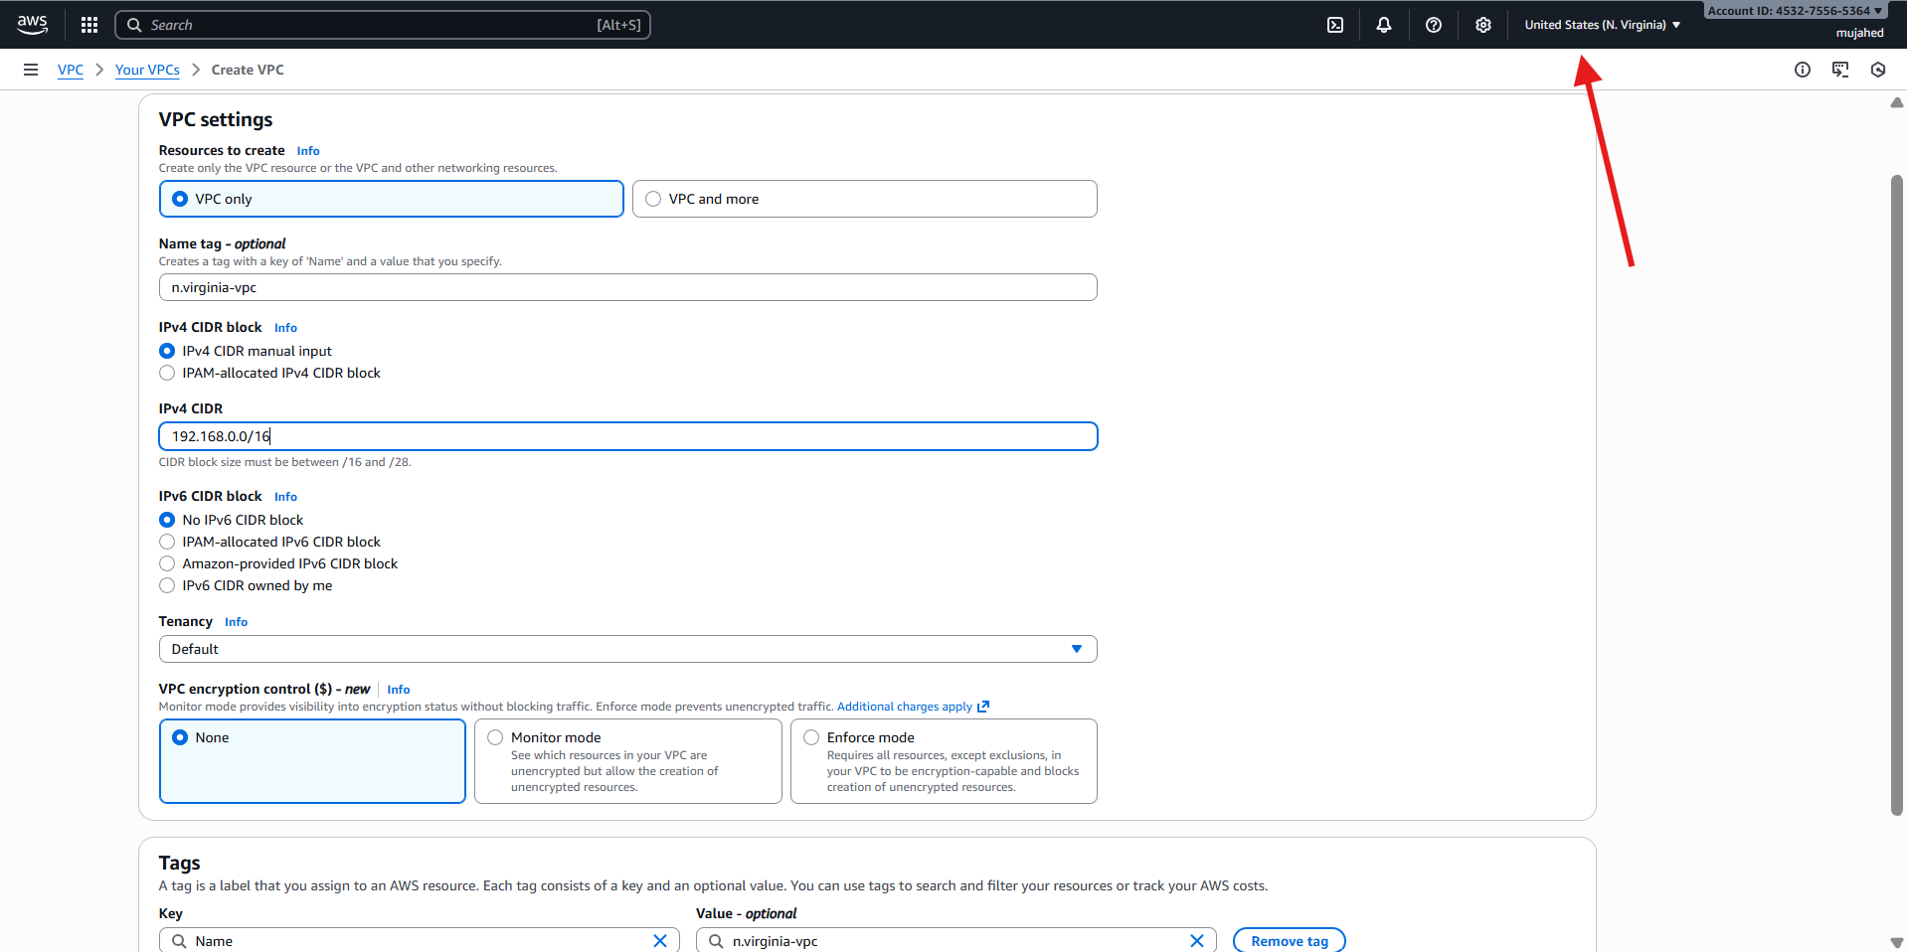

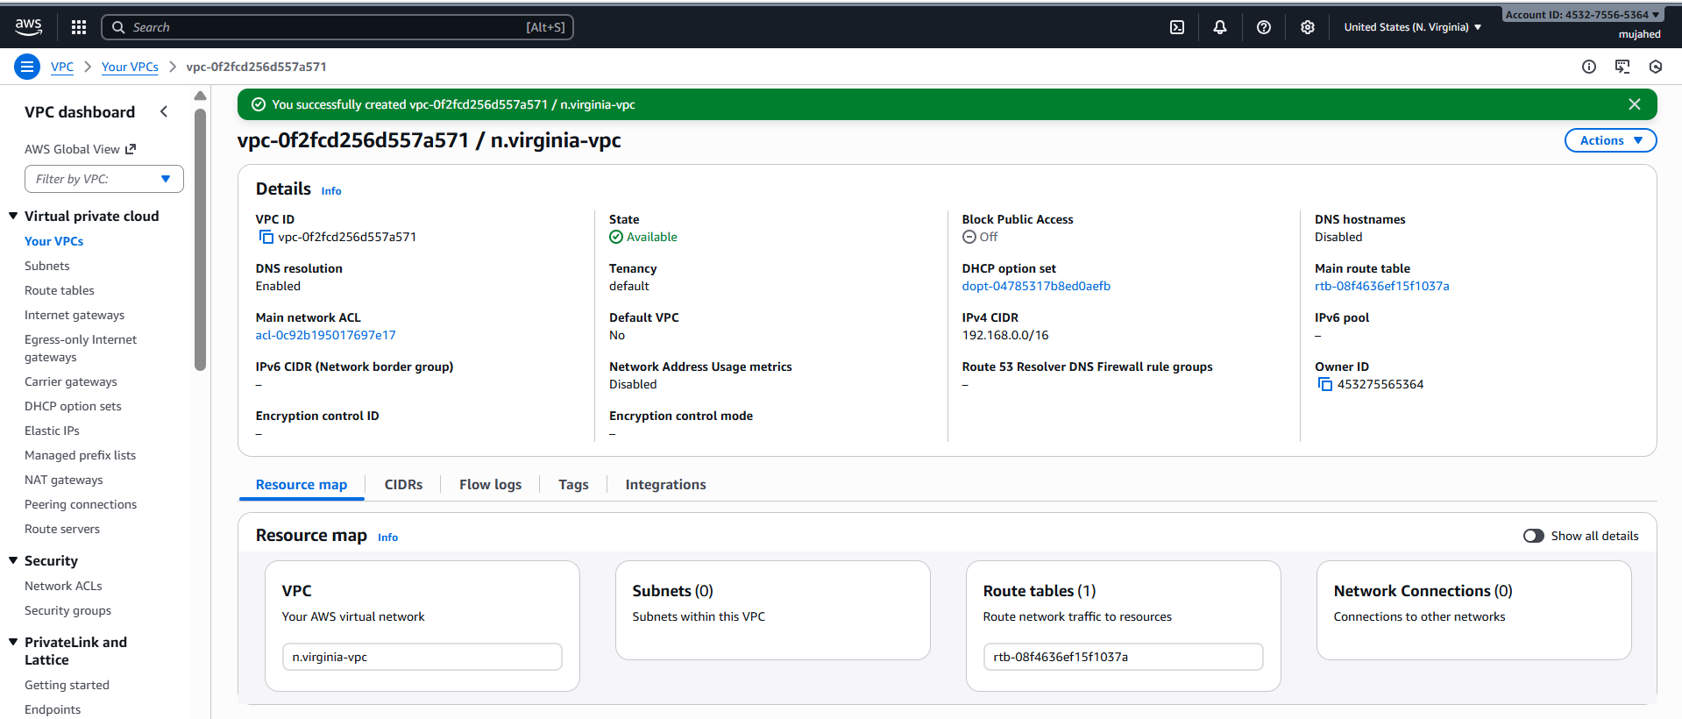

1. Create two subnets: one public subnet and one private subnet.
2. **Navigated to Subnets section**
   * AWS Console → **VPC Dashboard**
   * Left menu → Clicked on **Subnets**
   * Then clicked: **Create subnet**
3. **Selected the VPC**
   * VPC ID: **vpc-0f2cd256d557a571 (n.virginia-vpc)**  
     *(Same VPC created earlier with CIDR 192.168.0.0/16)*

**Subnet 1: Public Subnet**

1. **Configured first subnet**
   * Subnet name: **PUBLIC-SUBNET**
   * Availability Zone: **us-east-1a** (N. Virginia)
   * IPv4 subnet CIDR block: **192.168.0.0/26**
     + This allows for 62 usable IPs
   * Added TAG:
     + Name: **PUBLIC-SUBNET**

**Subnet 2: Private Subnet**

1. **Added second subnet**
   * Clicked on **Add new subnet**
   * Subnet name: **PRIVATE-SUBNET**
   * Availability Zone: **us-east-1a**
   * IPv4 subnet CIDR block: **192.168.0.64/26**
     + This allows another 62 usable IPs
   * Added TAG:
     + Name: **PRIVATE-SUBNET**
2. **Clicked "Create subnet"**
   * AWS successfully created **2 subnets**:
     + PUBLIC-SUBNET → 192.168.0.0/26
     + PRIVATE-SUBNET → 192.168.0.64/26

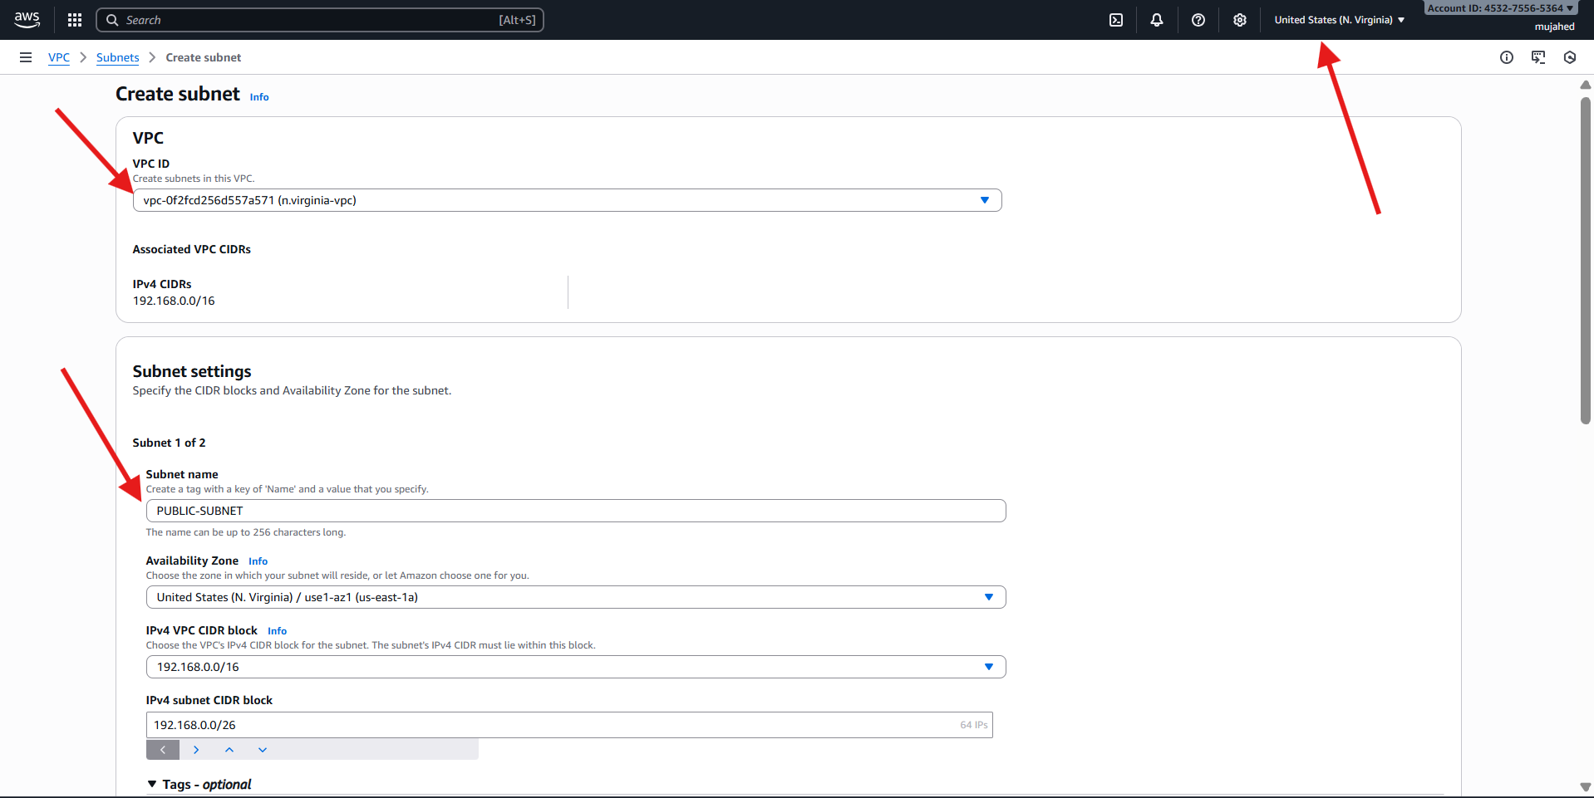

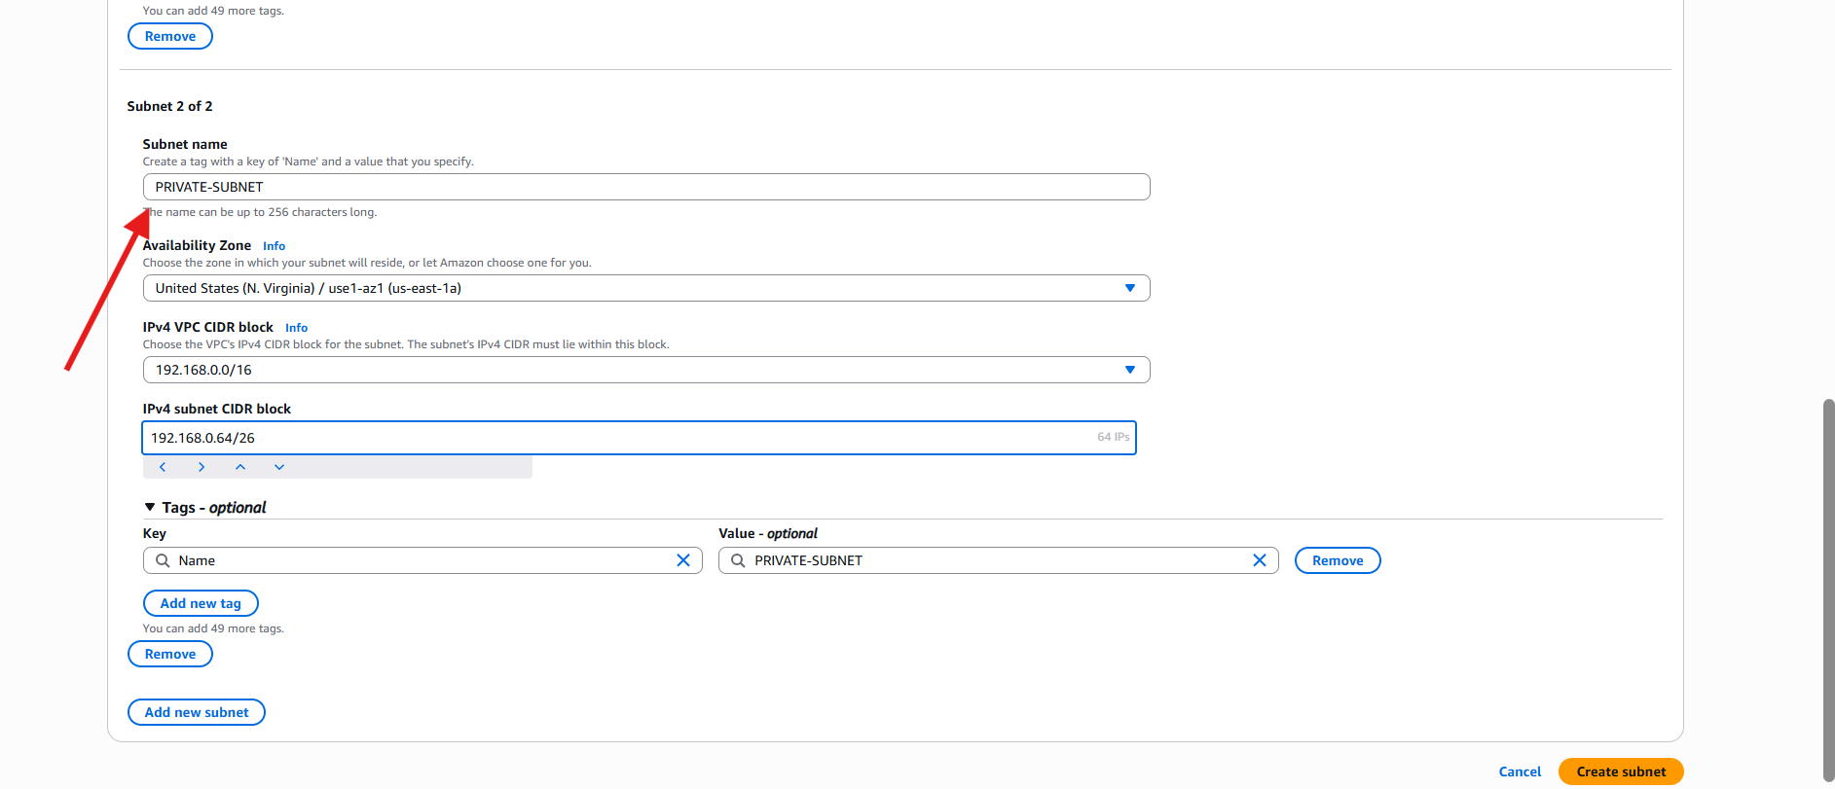

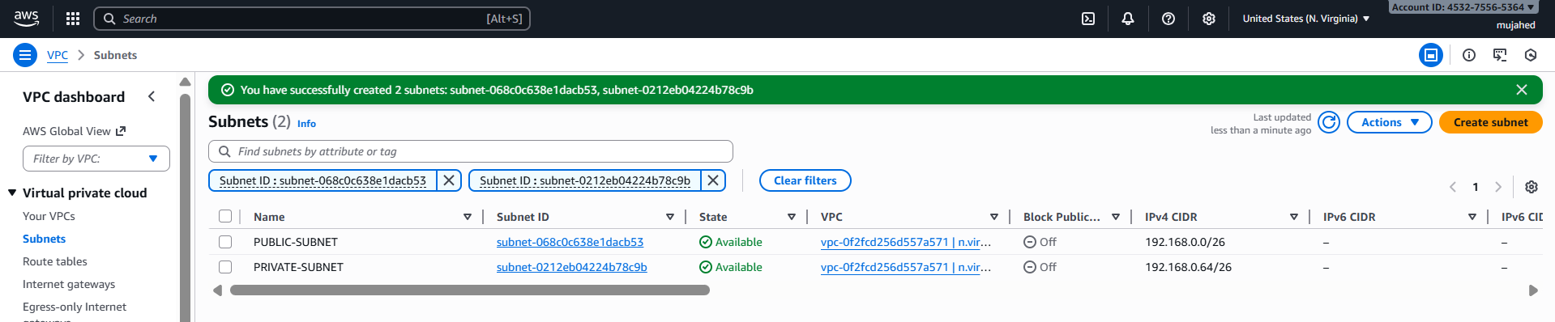

1. Attach an IGW to the VPC.

**Navigated to Internet Gateways**

* In the AWS VPC Dashboard
* Clicked **Internet gateways**
* Then clicked **Create internet gateway**

**Created an Internet Gateway**

**Attached IGW to VPC**

* Clicked **Attach to a VPC**
* Selected VPC: **vpc-0f2cd256d557a571 (n.virginia-vpc)**
* Clicked **Attach internet gateway**
* IGW is now **attached** to VPC and ready for internet traffic

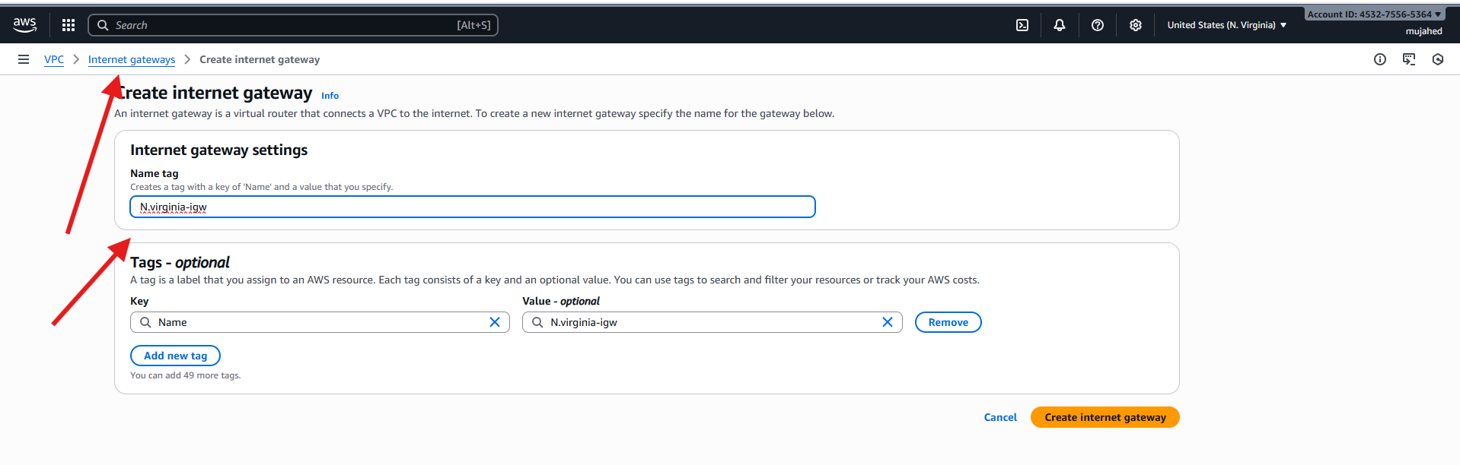

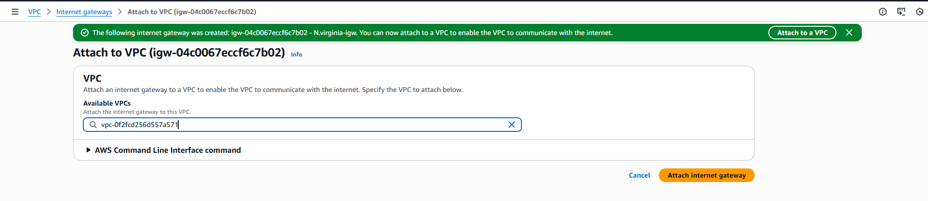

1. Create one public route (RT) and one private route table
2. **Navigated to Route Tables**
   * In the AWS VPC Dashboard → **Route tables**
   * Clicked **Create route table**

**Route Table 1: PUBLIC-RT**

1. **Created Public Route Table**
   * Name: **PUBLIC-RT**
   * Selected VPC: **vpc-0f2cd256d557a571 (n.virginia-vpc)**
     + Key: **Name**
     + Value: **PUBLIC-RT**
   * Clicked **Create route table**

**Route Table 2: PRIVATE-RT**

1. **Created Private Route Table**
   * Name: **PRIVATE-RT**
   * Selected VPC: **same VPC**
     + Key: **Name**
     + Value: **PRIVATE-RT**

Clicked **Create route table**

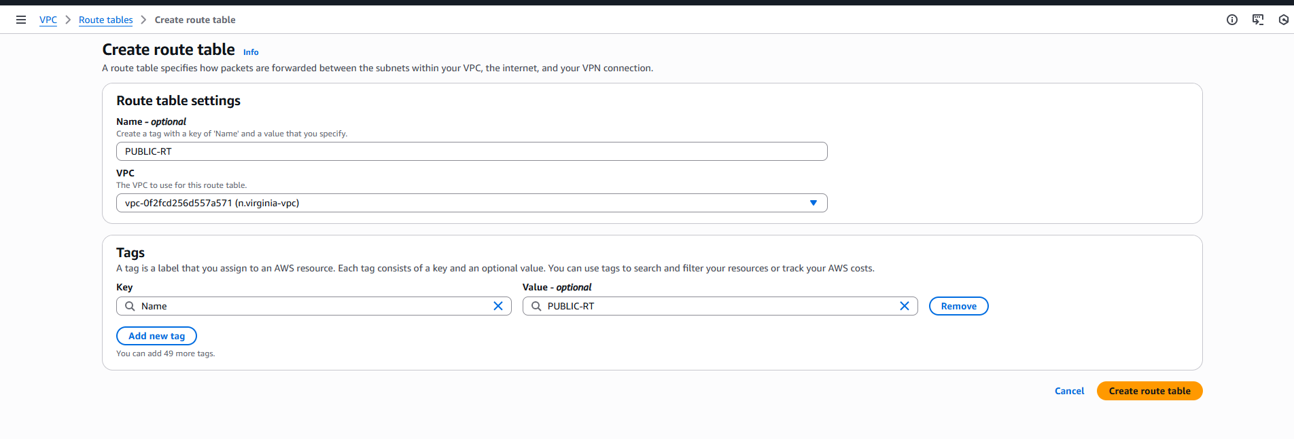

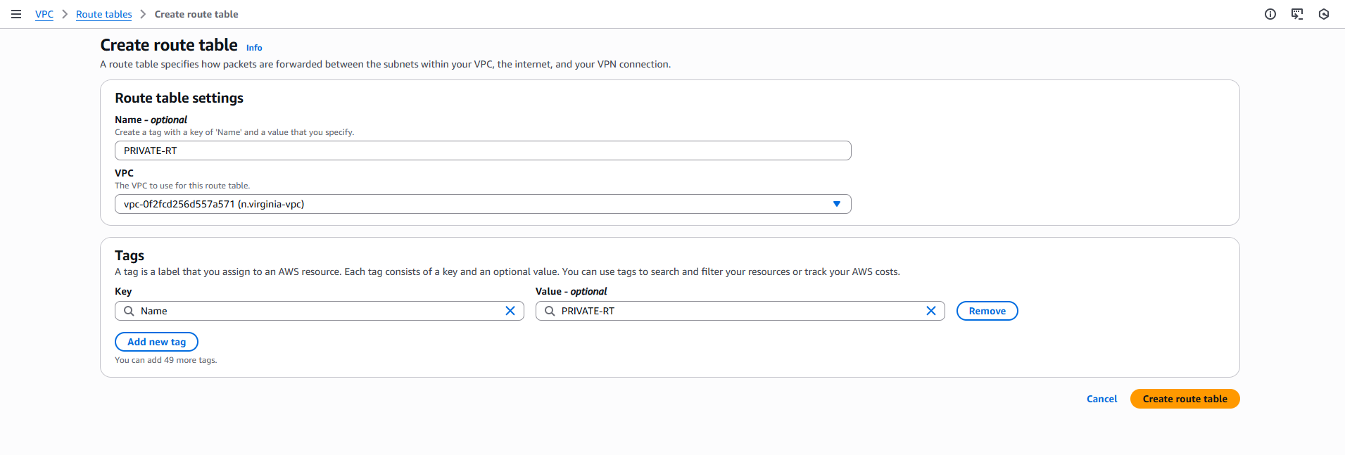

1. Deploy a NAT gateway in the public subnet and attach the NAT gateway to the private subnet.

**1️⃣ Create a NAT Gateway**

Navigated to **NAT Gateways** → **Create NAT gateway**

Name: **N.virginia-nat**

Availability Mode: **Regional**

VPC: **n.virginia-vpc**

Connectivity type: **Public** (this automatically attaches an Elastic IP)

Method of Elastic IP: **Automatic**

Added Tag: N.virginia-nat

Clicked: **Create NAT gateway**

NAT created: **nat-1b90259657ff310a0**

**2️⃣ Associate Route Tables with Subnets**

**A. PUBLIC-RT Association**

Navigated to **Route tables**

Selected: **PUBLIC-RT**

Chose **Edit subnet associations**

Selected **PUBLIC-SUBNET**

Clicked **Save associations**

*This makes the subnet a public subnet once the IGW route is added.*

**B. PRIVATE-RT Association**

Selected: **PRIVATE-RT**

Clicked **Edit subnet associations**

Selected **PRIVATE-SUBNET**

Clicked **Save associations**

*This links the Private Subnet to PRIVATE-RT.*

**3️⃣ Add Internet Route for Private Subnet via NAT**

Selected **PRIVATE-RT**

Opened **Routes** → **Edit routes**

Added:

Destination: **0.0.0.0/0**

Target: **NAT Gateway**

NAT: **nat-1b90259657ff310a0**

Clicked **Save changes**

This gives the **Private Subnet outbound internet connectivity**, without being exposed to inbound public access

**4️⃣ Validation via Resource Map**

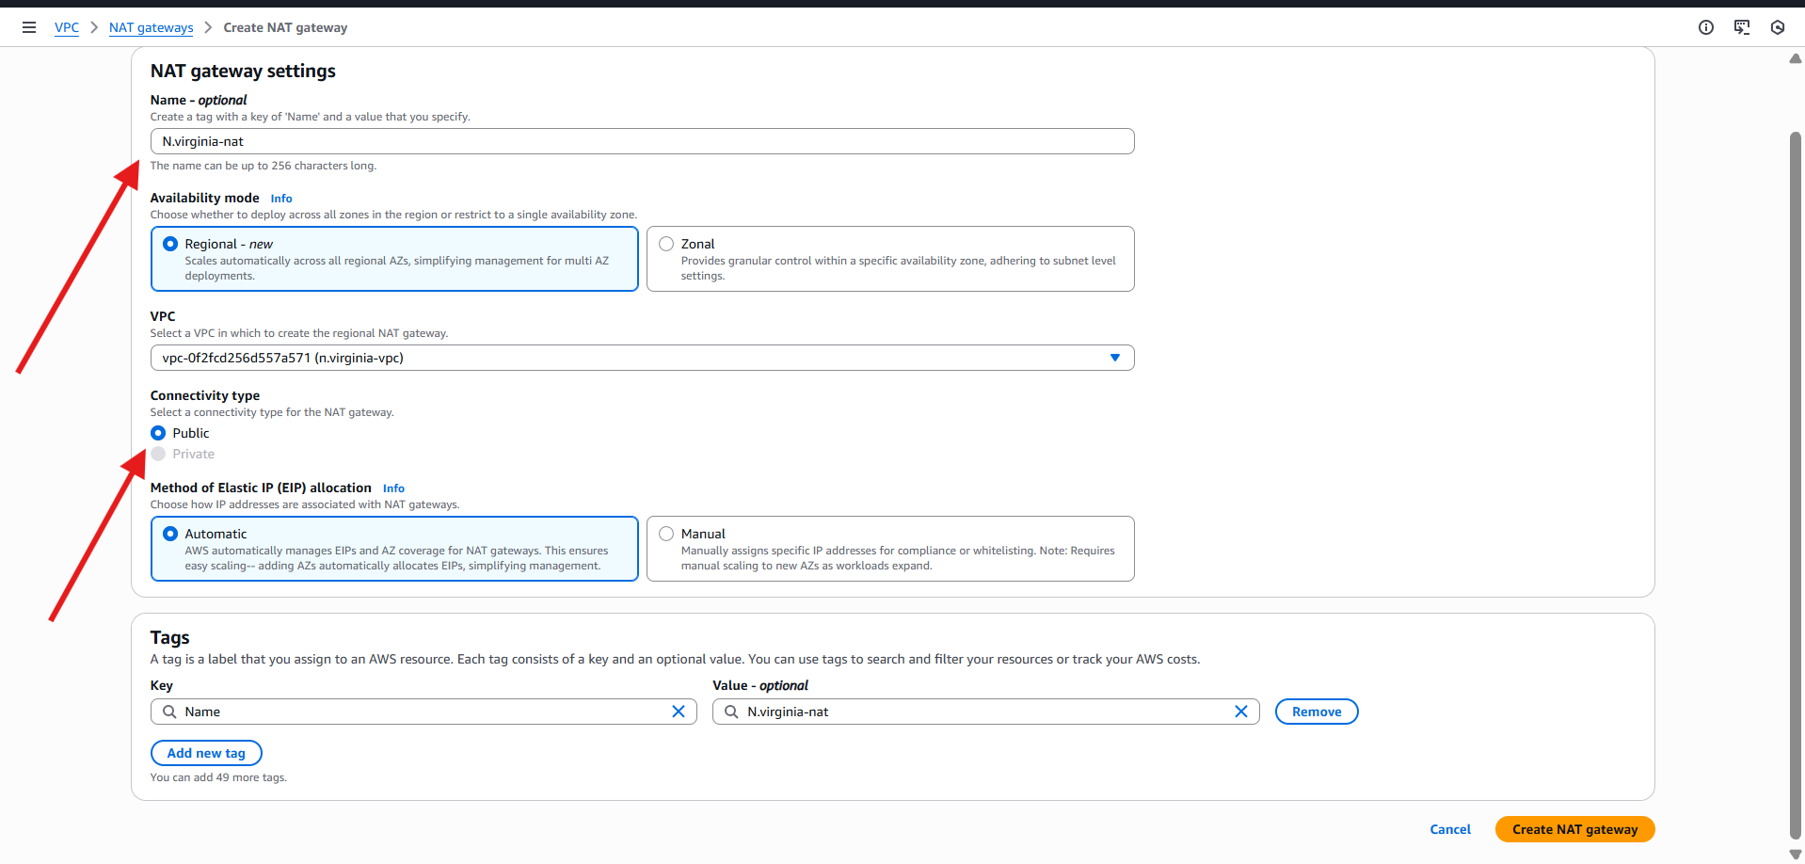

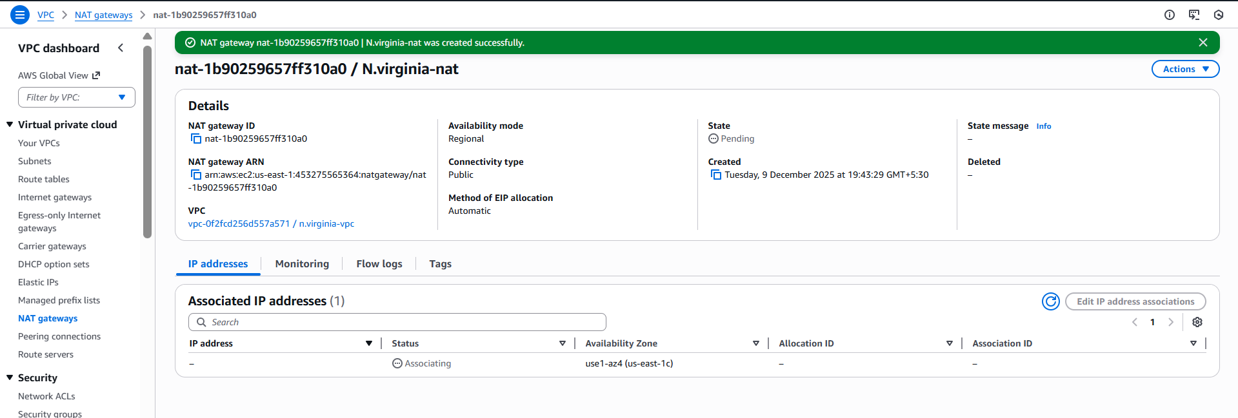

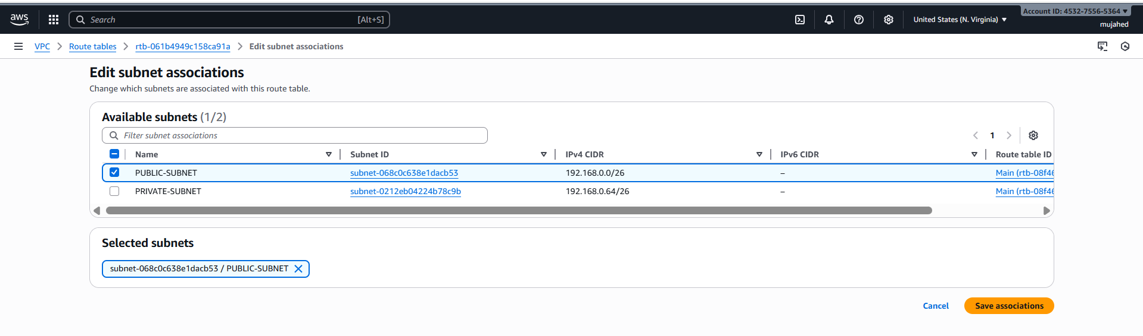

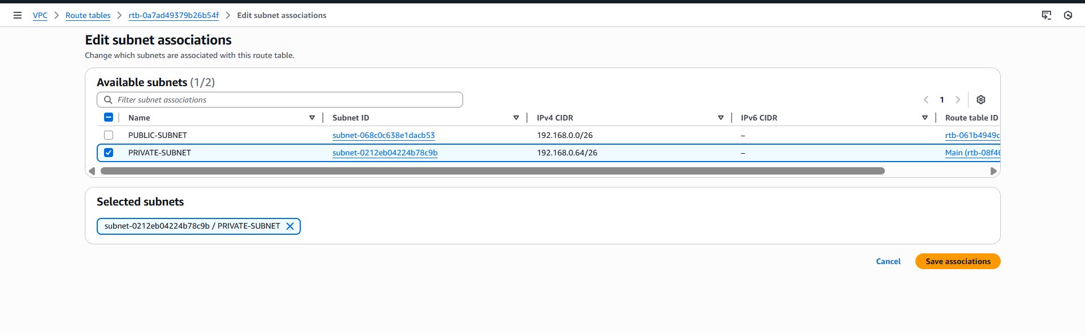

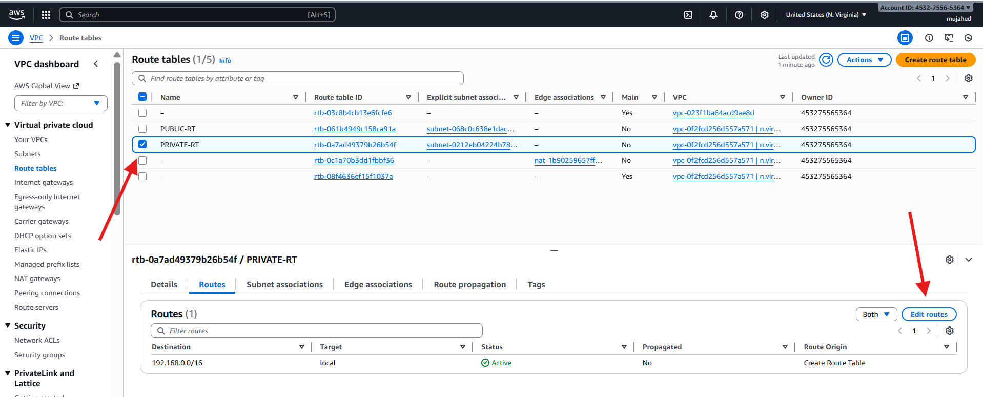

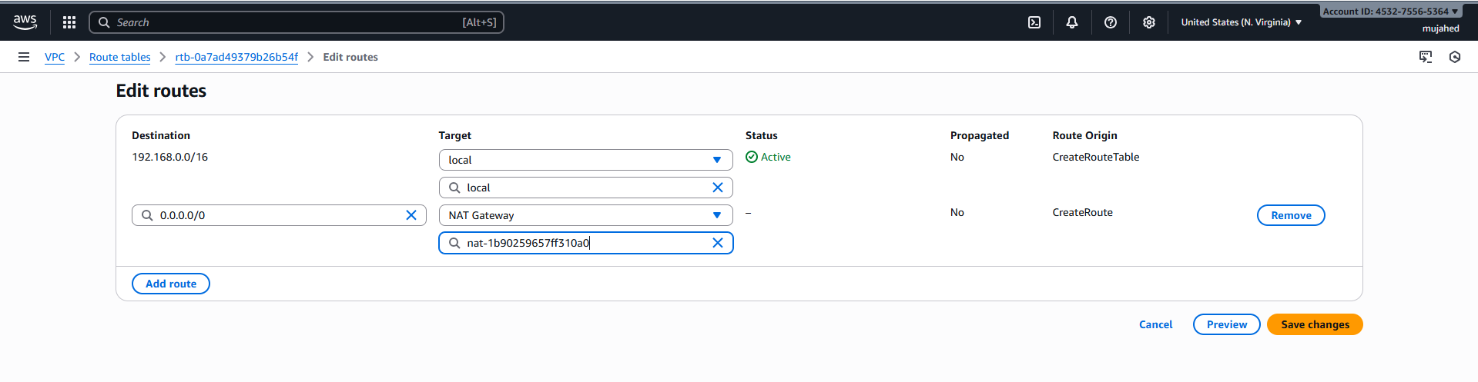

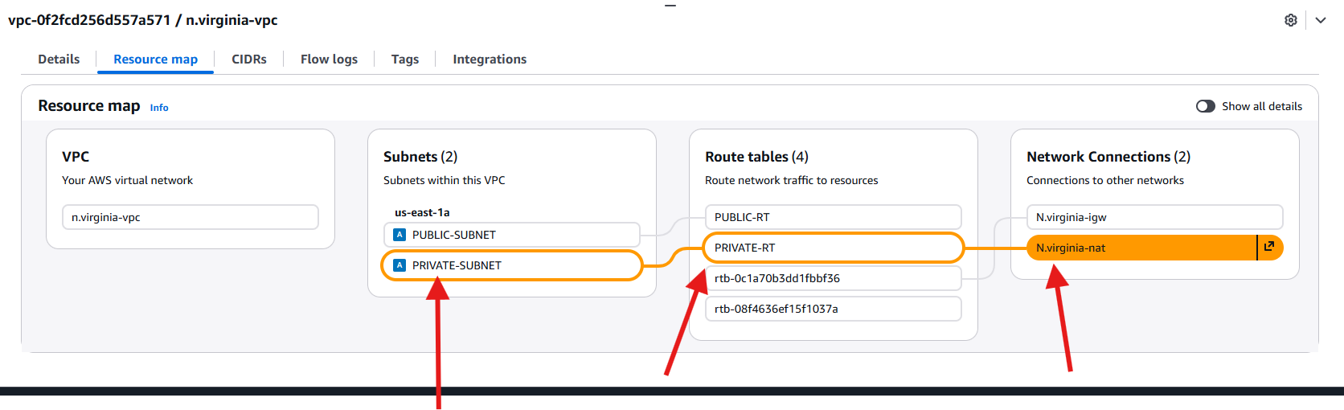

1. Create two instances, one in the public subnet and one in the private subnet.

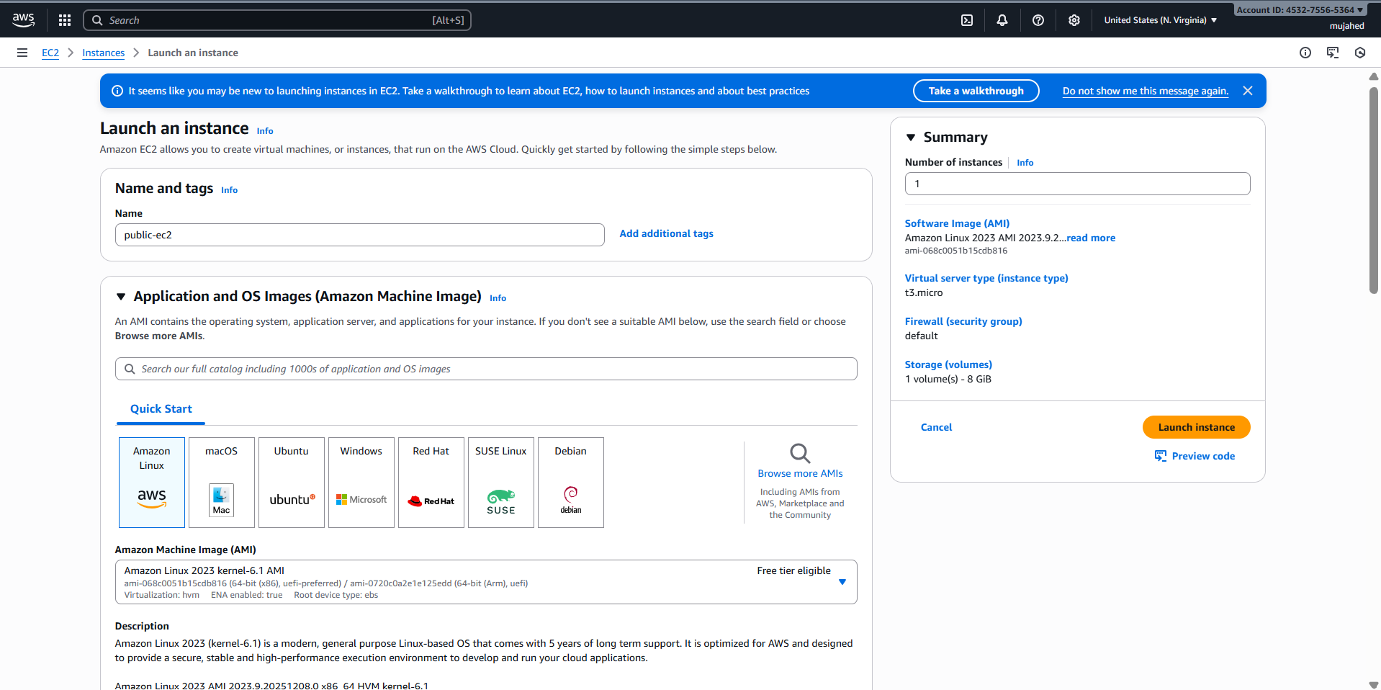

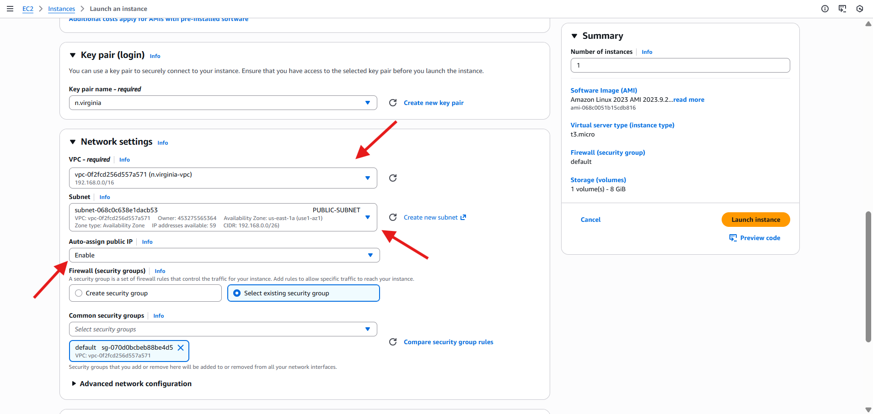

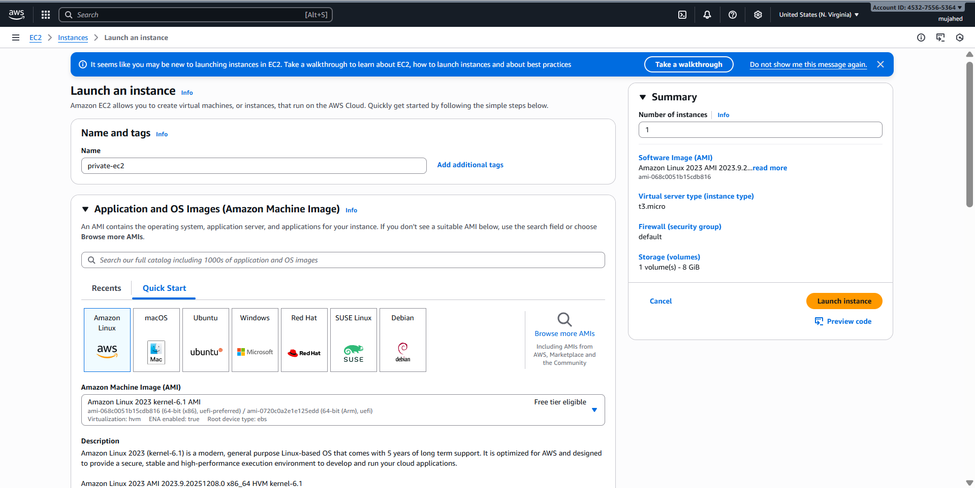

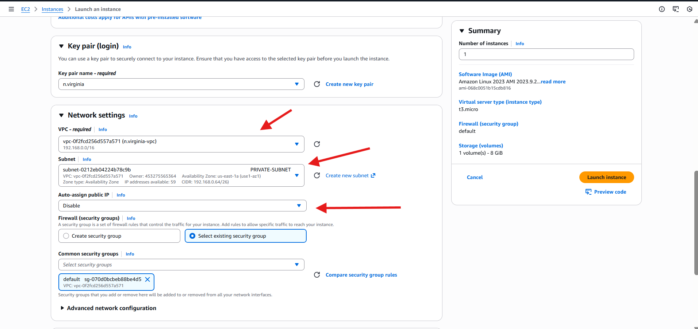

1. Deploy Apache server on both EC2 instances with a sample index.html file.

**1️⃣ Connected to Public EC2 Instance**

Command used:

ssh -i "n.virginia.pem" ec2-user@<Public-IP>

Successfully logged in to the **Public EC2** Linux server

**2️⃣ Installed & Configured Apache on Public EC2**

Commands executed:

sudo su -

yum install httpd -y

systemctl start httpd

systemctl enable httpd

systemctl status httpd

echo "<h1>Welcome! This is the Public EC2 Web Server.</h1>" > /var/www/html/index.html

Apache Web Server started  
 Index page created

Browser validation:  
Public EC2 IP → Shows webpage:

**Welcome! This is the Public EC2 Web Server.**

**3️⃣ Used Public EC2 as a Bastion Host (Jump Server)**

➡️ This enables access to Private EC2 via SSH

You verified the key permissions:

chmod 600 test.pem

Then SSH into Private instance:

ssh -i test.pem ec2-user@192.168.0.104

Successfully logged into Private EC2

**4️⃣ Installed & Configured Apache on Private EC2**

Commands performed:

sudo su -

yum install httpd -y

systemctl start httpd

systemctl enable httpd

systemctl status httpd

echo "<h1>Welcome! This is the Private EC2 Web Server.</h1>" > /var/www/html/index.html

curl http://localhost/

Apache running privately  
 Local HTTP check succeeded:

**Welcome! This is the Private EC2 Web Server.**

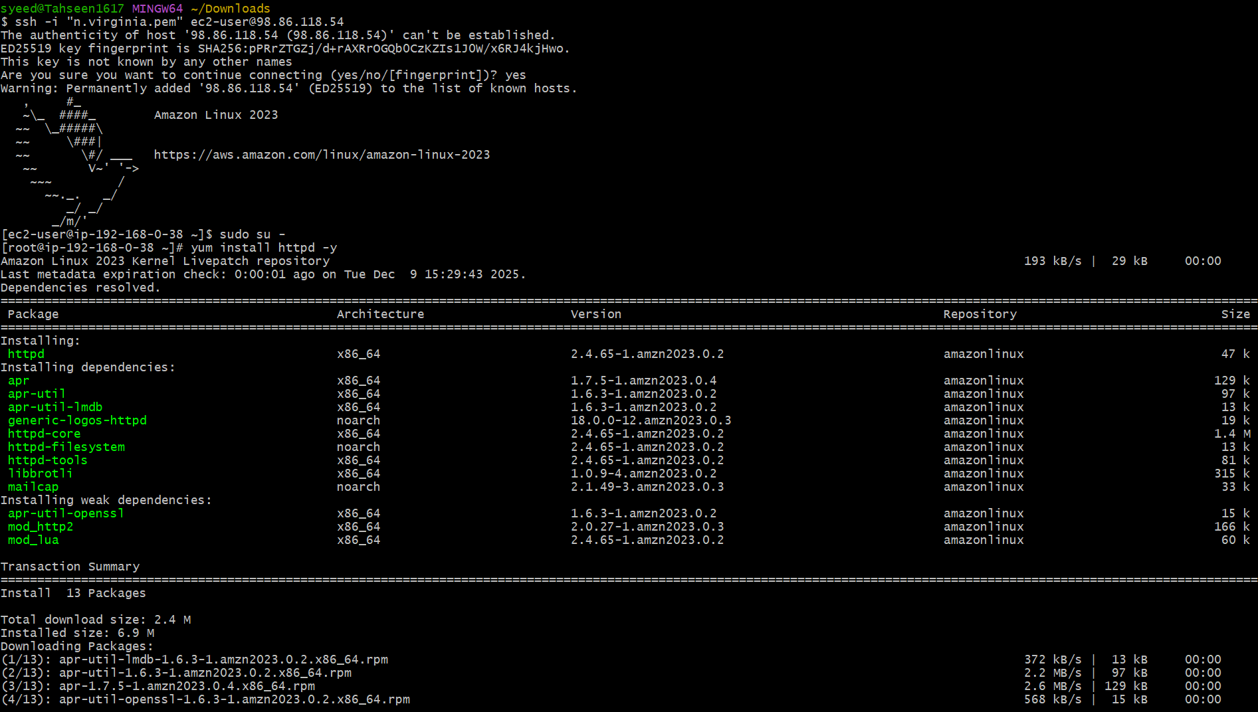

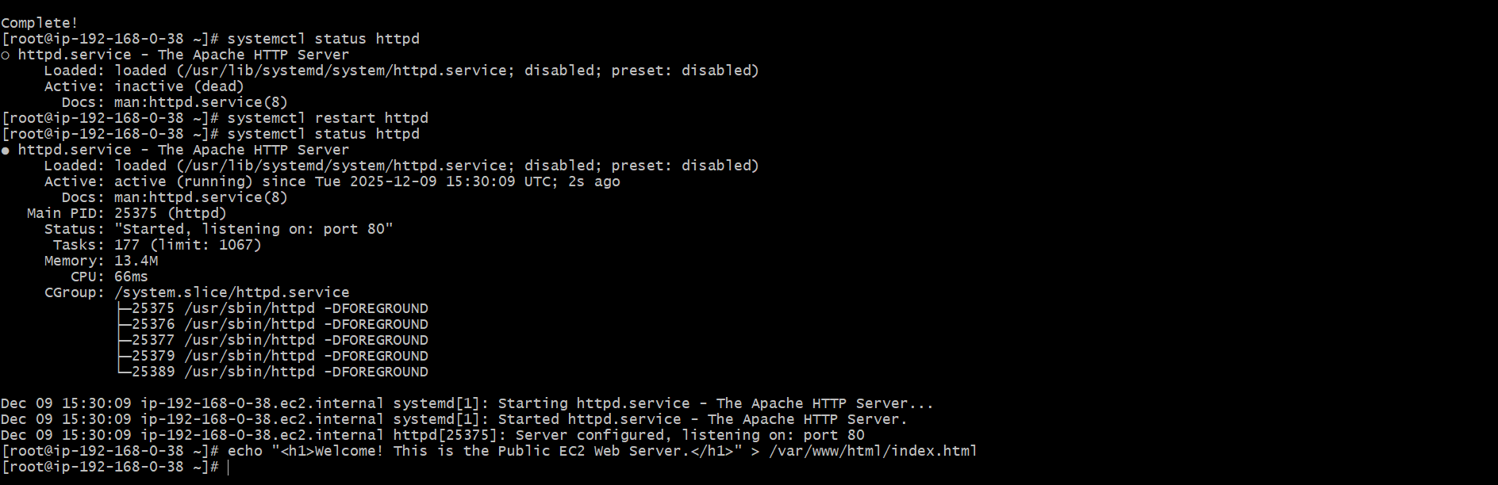



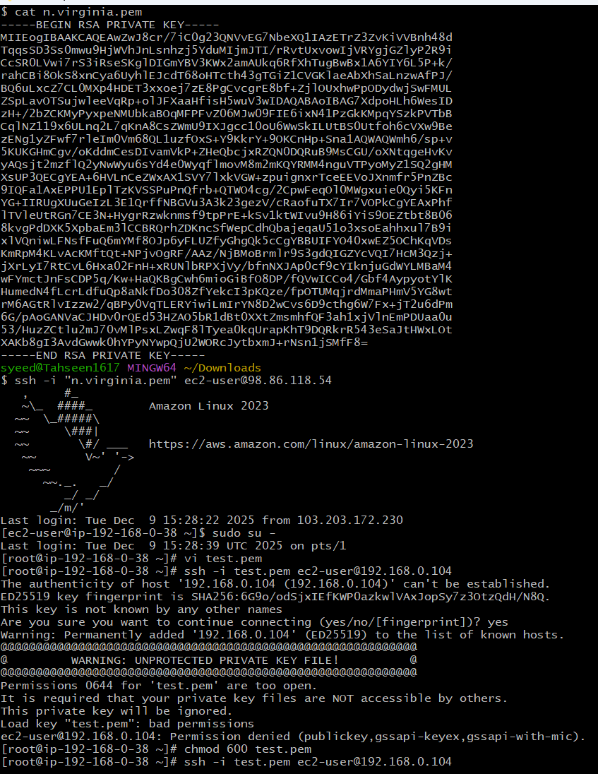

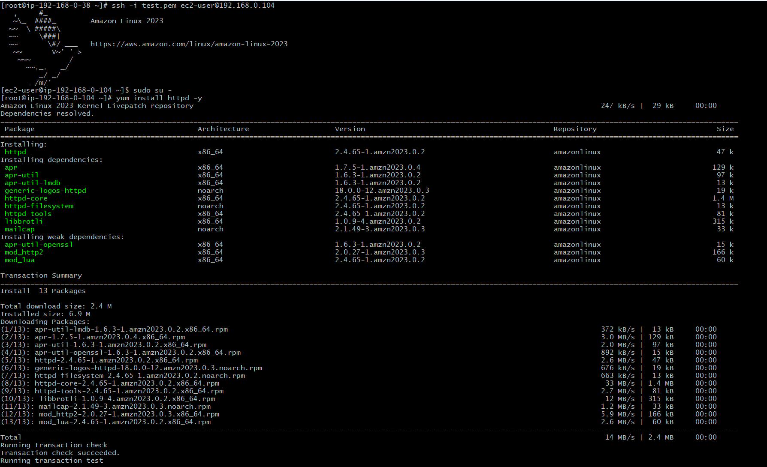

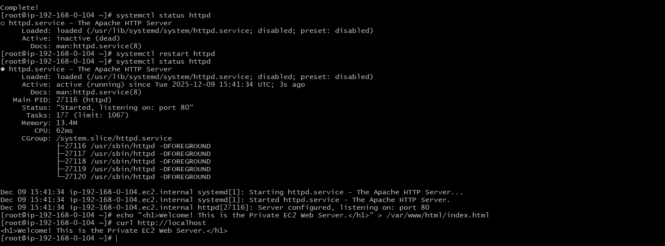

1. Create one application load balancer and attach it to both EC2 instances.

**1️⃣ Create a Target Group**

* Went to **EC2 Console → Target groups → Create target group**
* Selected **Instance** as target type
* Name: **target-ec2**
* Protocol: **HTTP**
* Port: **80**
* Selected VPC: **n.virginia-vpc**
* Health check configuration:
  + Protocol: **HTTP**
  + Path: **/**

**Registered both EC2 instances**

| **Instance** | **Subnet** | **Port** | **Type** |
| --- | --- | --- | --- |
| public-ec2 | PUBLIC-SUBNET | 80 | Web server |
| private-ec2 | PRIVATE-SUBNET | 80 | Web server |

➡ Both instances status **Healthy**

**2️⃣ Create Application Load Balancer**

* Go to **Load Balancers → Create Load Balancer**
* Selected **Application Load Balancer**
* Load balancer name: **my-alb**
* Scheme: **Internet-facing**
* IP Address Type: **IPv4**

**Network Mapping**

* VPC: **n.virginia-vpc**
* Selected subnets:
  + **us-east-1a → PUBLIC-SUBNET**
  + **us-east-1b → Another subnet**
* Security group: **default**

**Listener Configuration**

* Listener protocol: **HTTP**
* Port: **80**
* Forwarding to target group: **target-ec2**

**Result After Deployment**

* ALB DNS opened in browser:
  + It showed content from **Public EC2**
  + It showed content from **Private EC2**
* Load Balancer successfully routing traffic to:  
   Public Instance  
   Private Instance

validated two different webpages:

| **Output** | **Shows** |
| --- | --- |
| Public output | “Welcome! This is the Public EC2 Web Server.” |
| Private output | “Welcome! This is the Private EC2 Web Server.” |

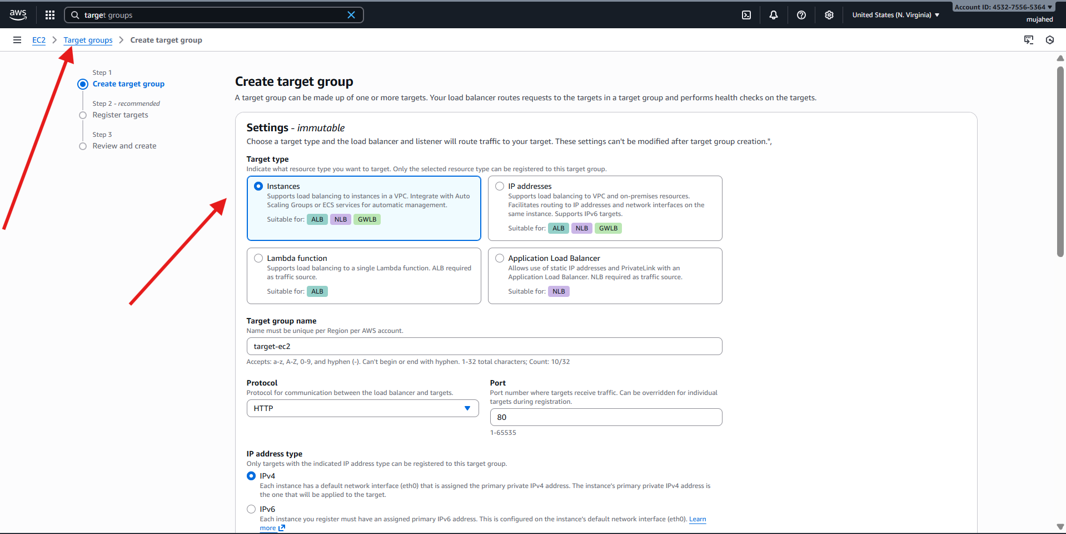

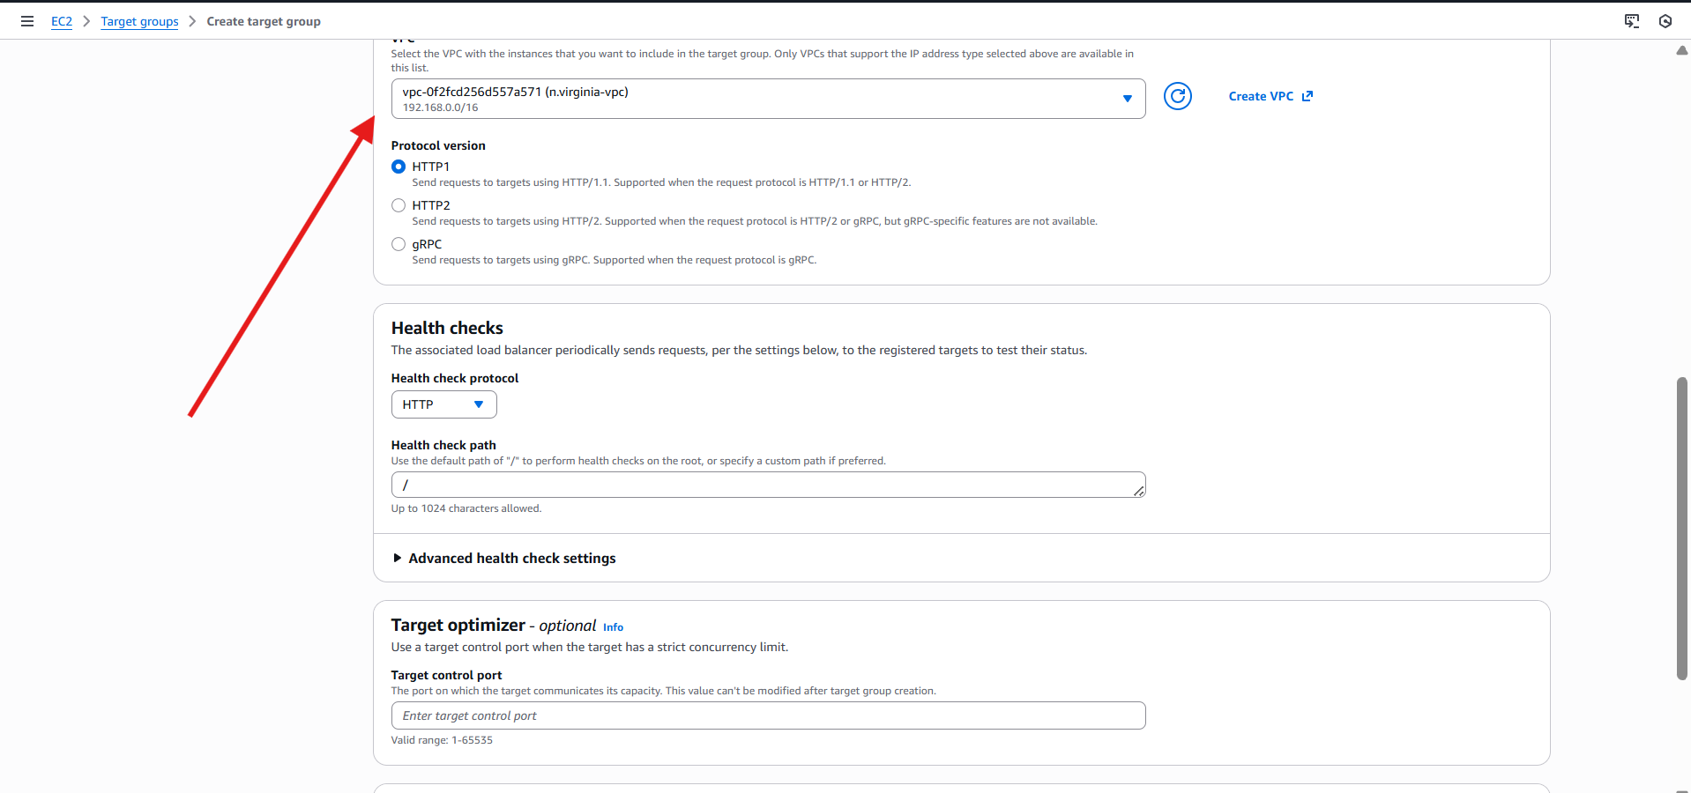

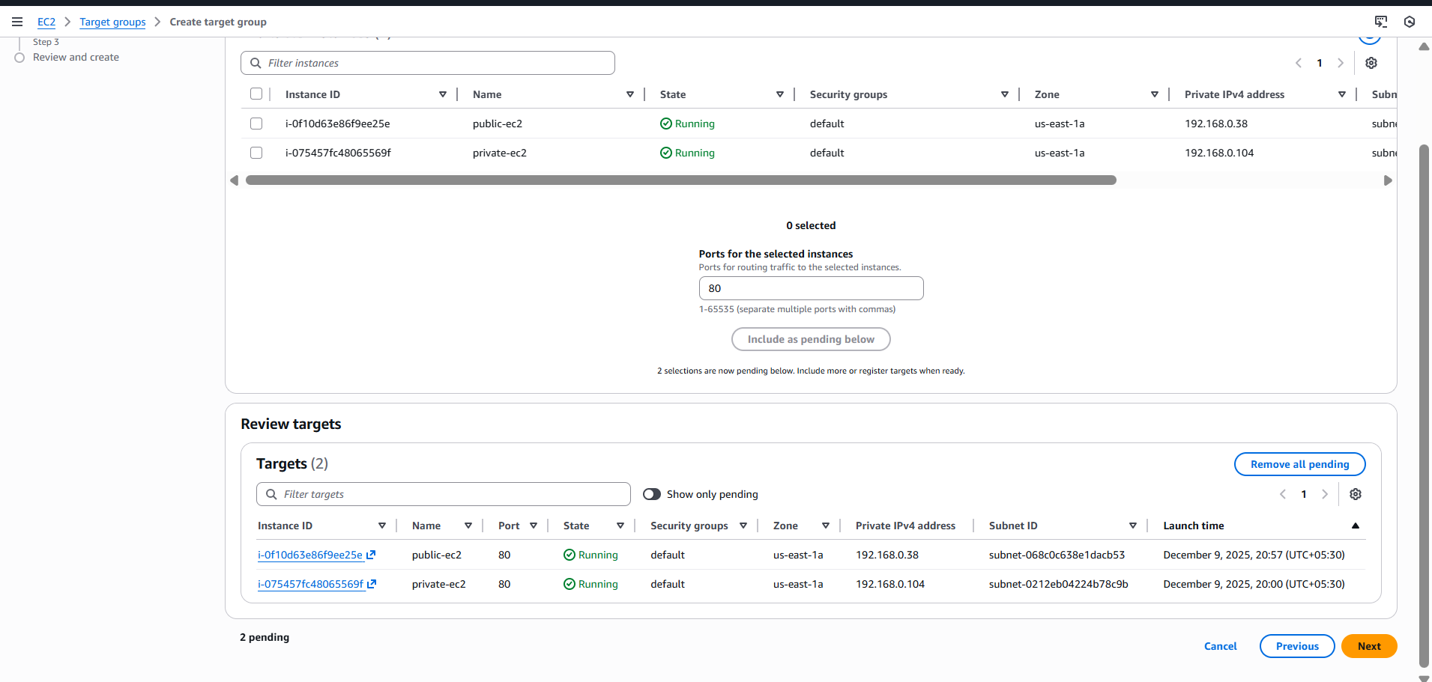

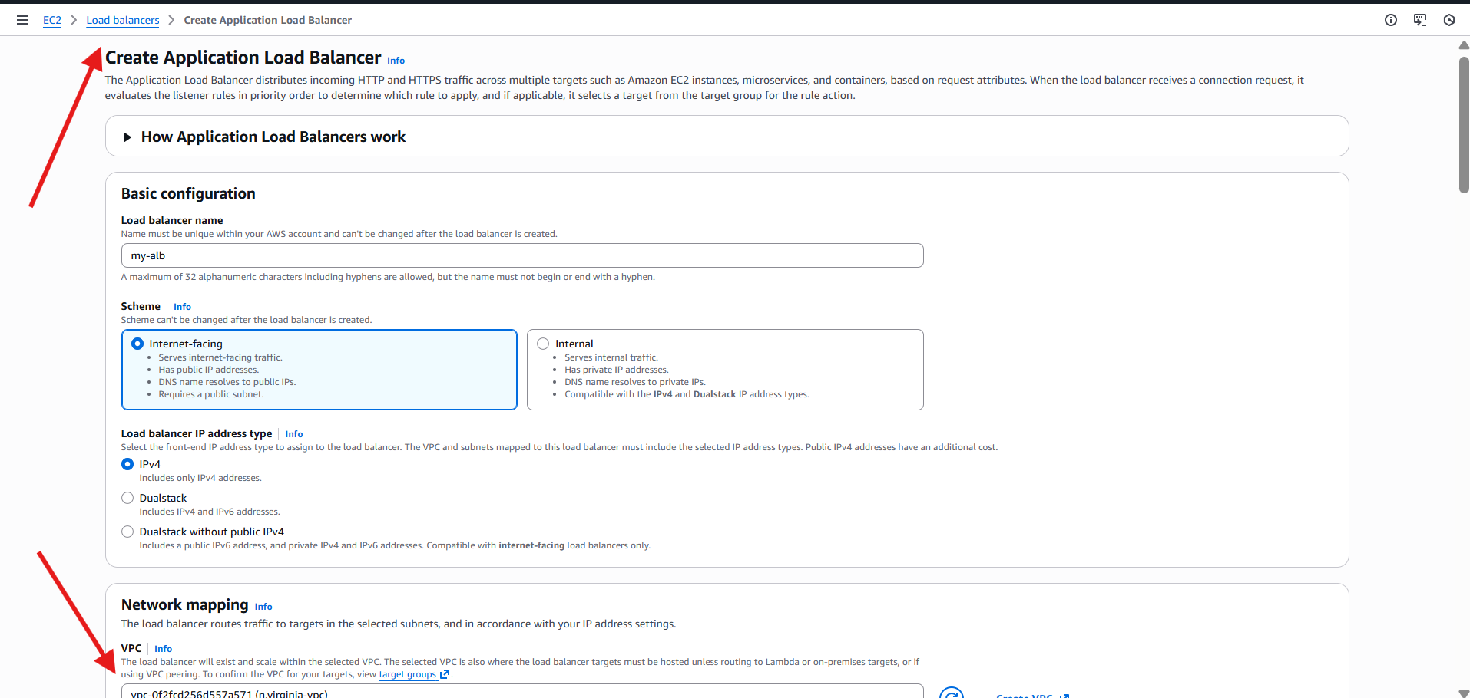

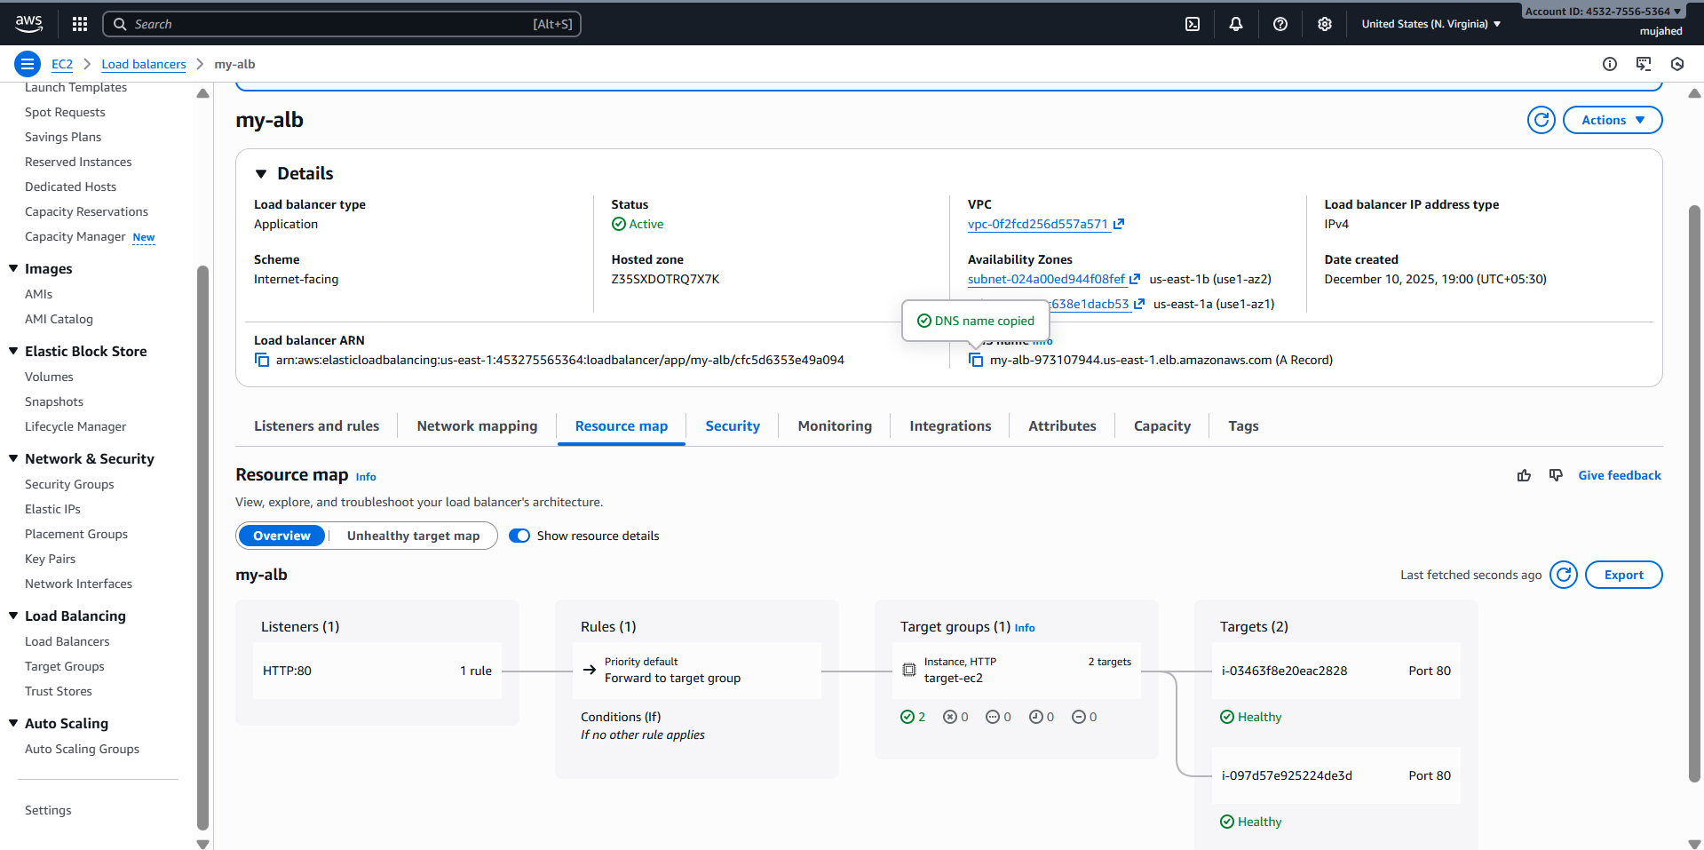

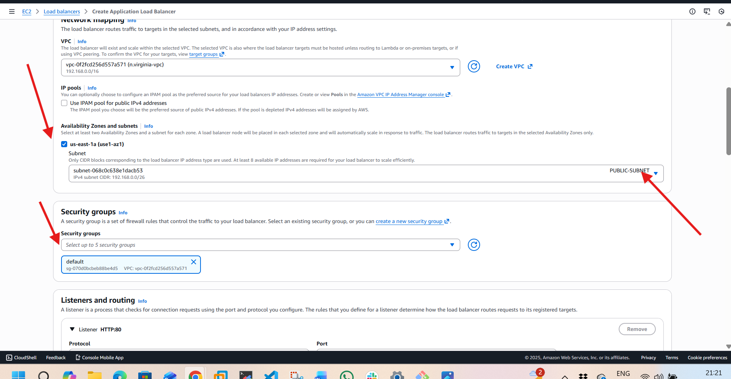





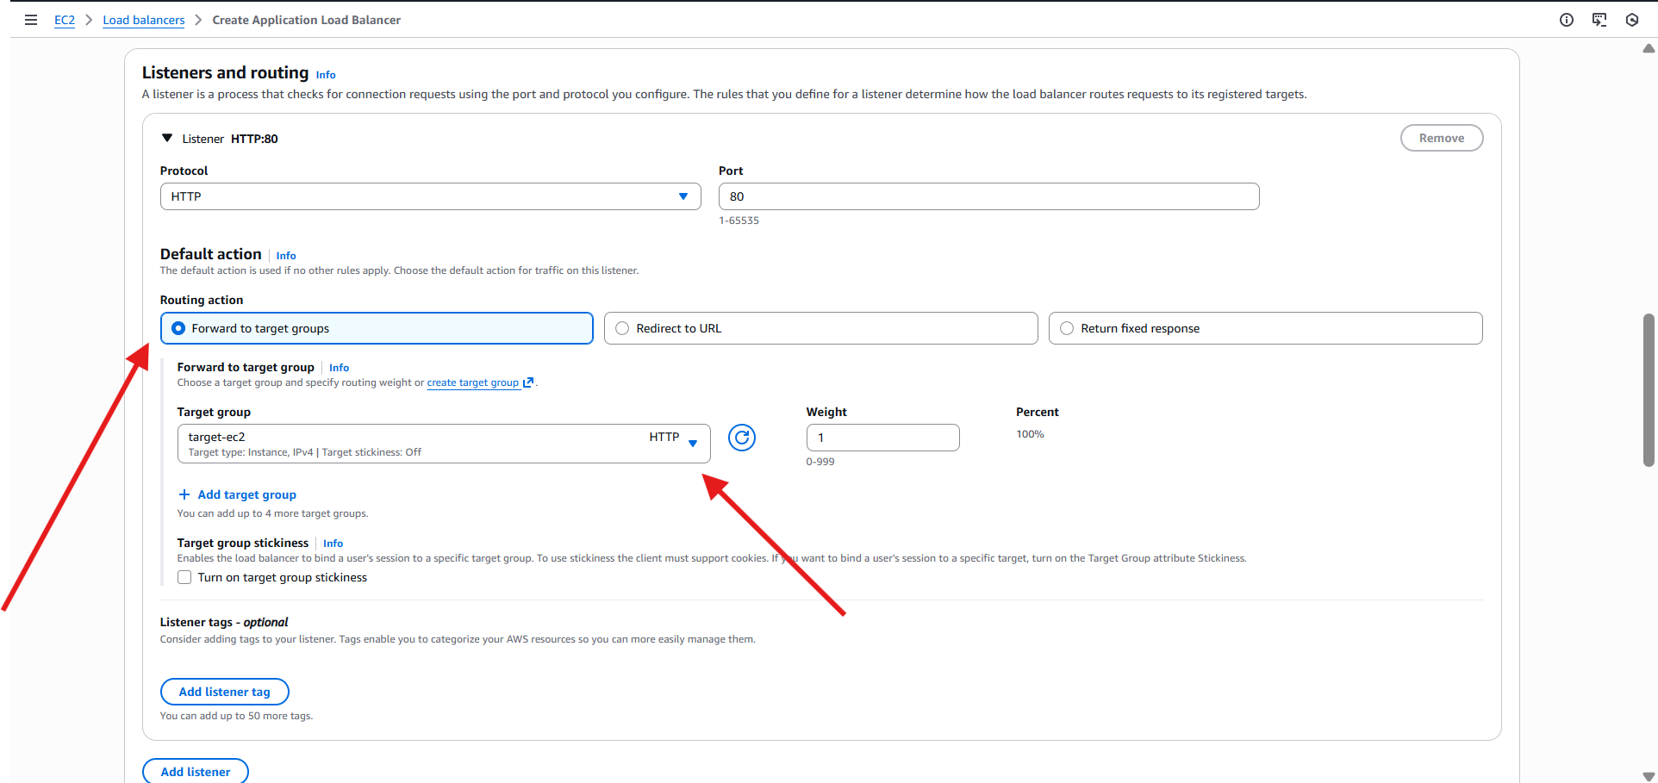

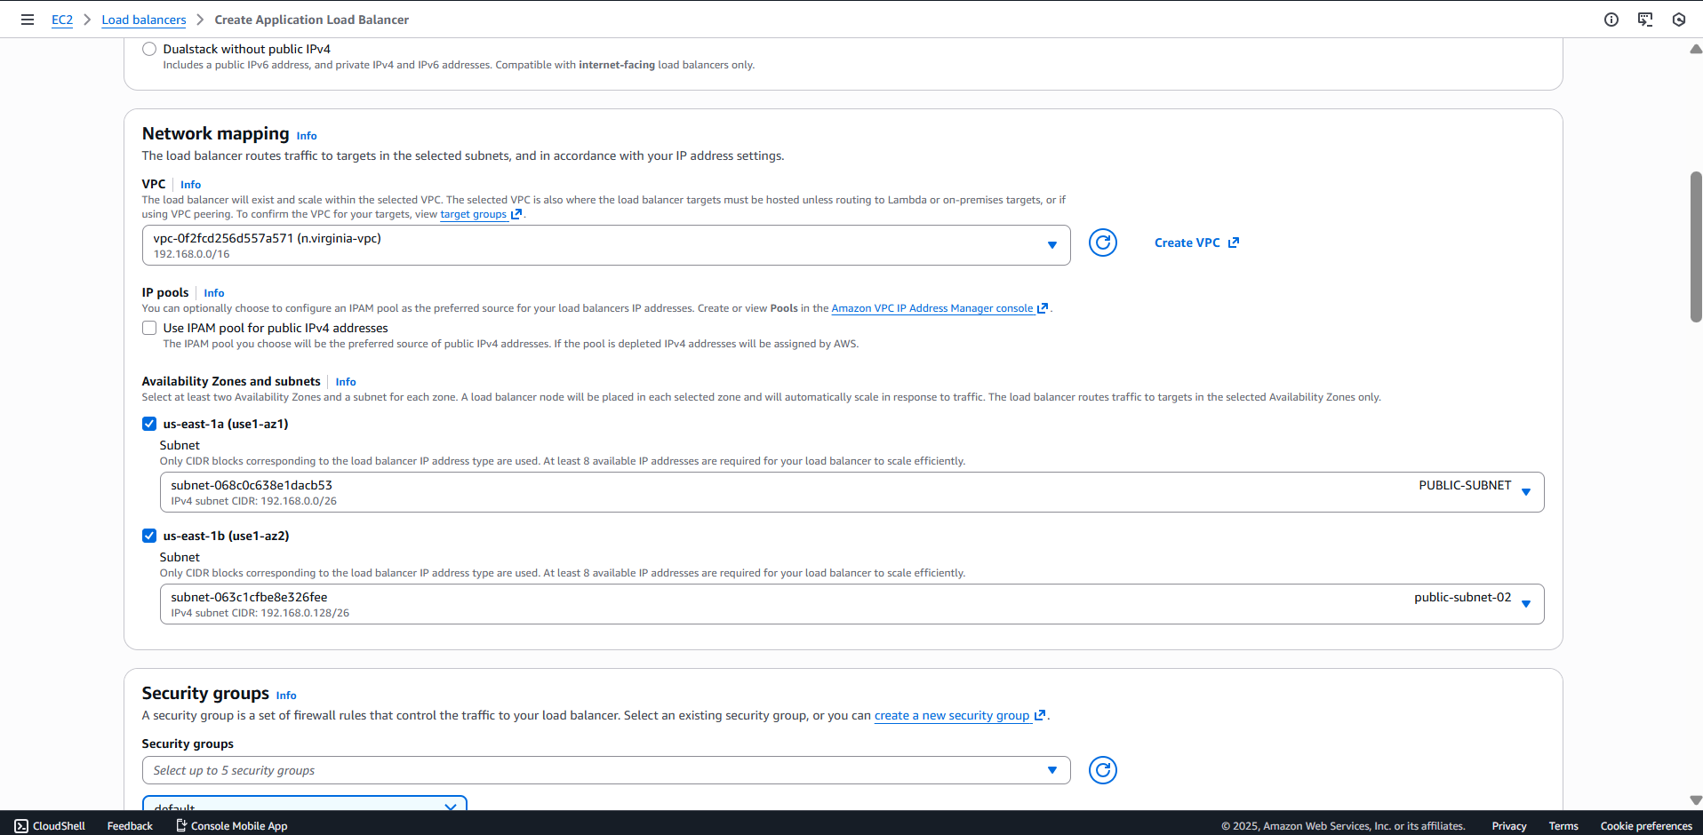

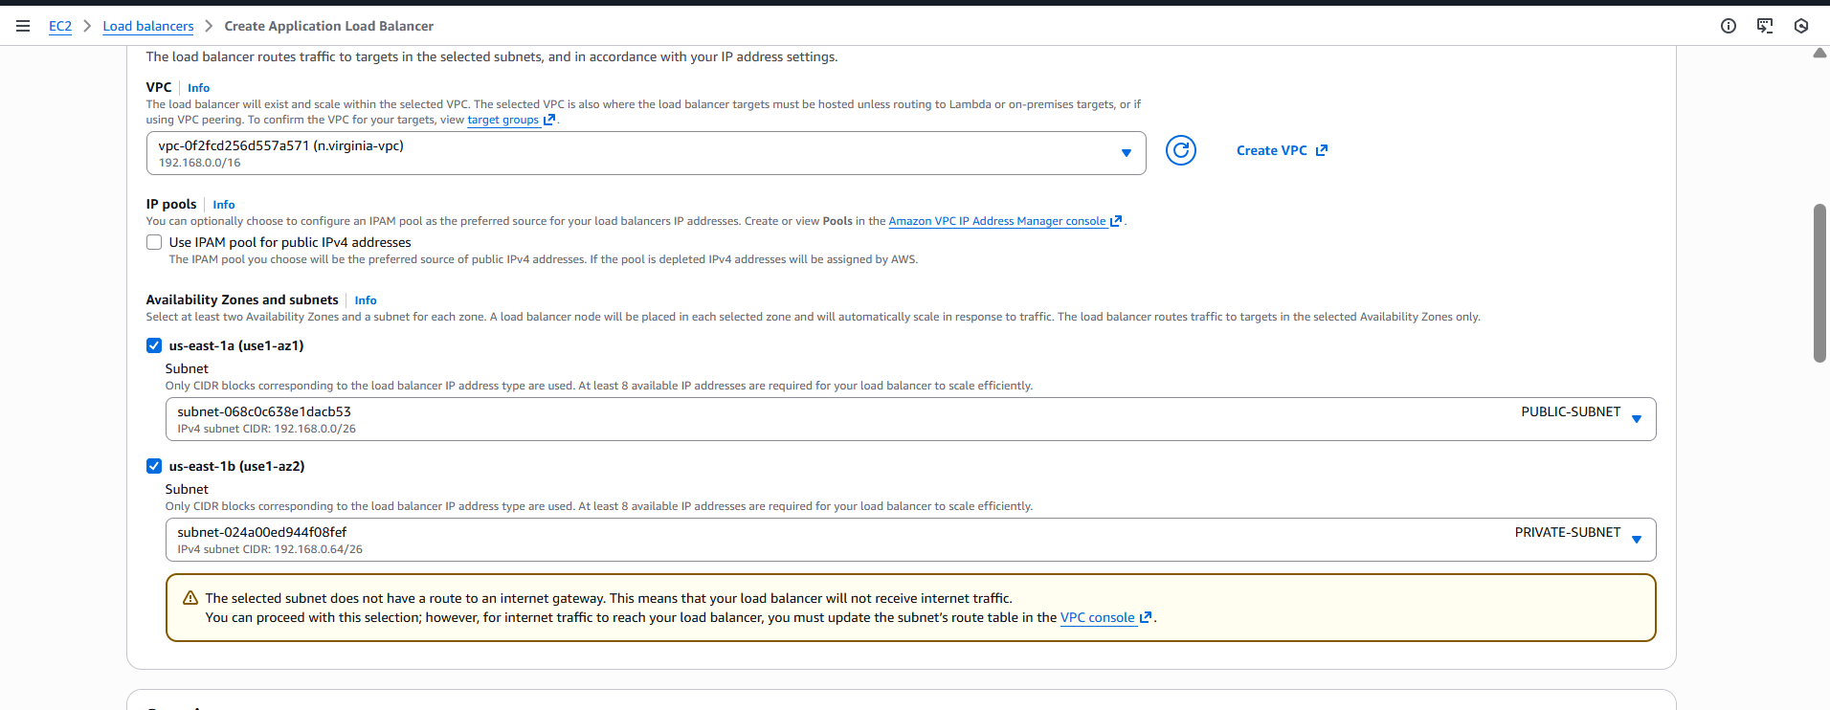

1. Store application load balancer logs in S3.

**1️⃣ Enable Access Logs in ALB Monitoring**

* Navigate to:  
  **EC2 → Load Balancers → my-alb → Edit attributes**
* Checked **Access logs**
* Provided S3 bucket URI:
* s3://load-balancer-logs-s3-n.virginia

First attempt failed:

Access Denied — S3 bucket permission issue

**2️⃣ Updated S3 Bucket Policy**

opened the S3 bucket where logs should be stored and added a correct ALB bucket policy.

Granted required permissions:

* s3:PutObject
* s3:GetBucketAcl

Scoped to correct **bucket ARN** and **prefix**

**Result:**

Policy was successfully applied  
 ALB was able to write logs to S3

**3️⃣ Verified Access Logs in S3 bucket**

* Navigated to:  
  **Amazon S3 → load-balancer-logs-s3-n.virginia**
* Logs folder **AWSLogs/** was automatically created
* Opened a log file → Verified entry:

**Enable AccessLog for ELB** app/my-alb/

This confirms logging is **working properly**

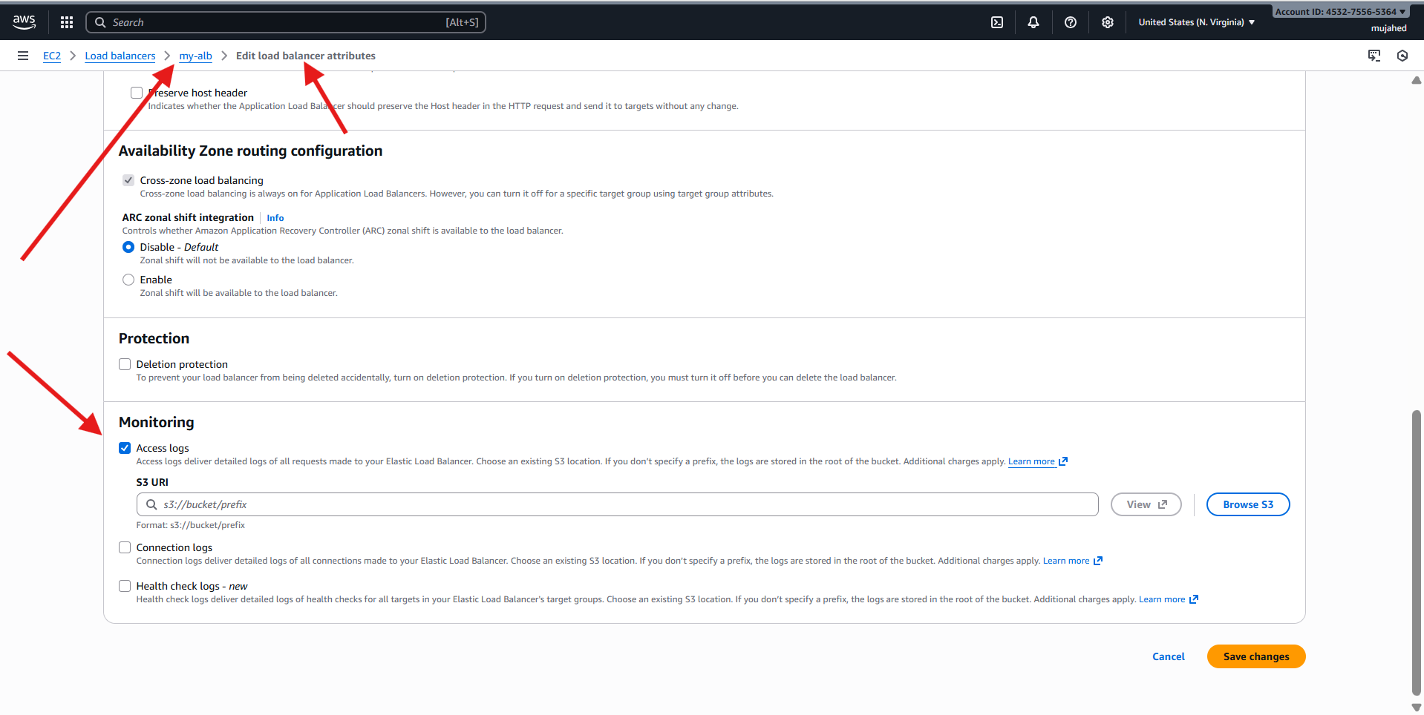

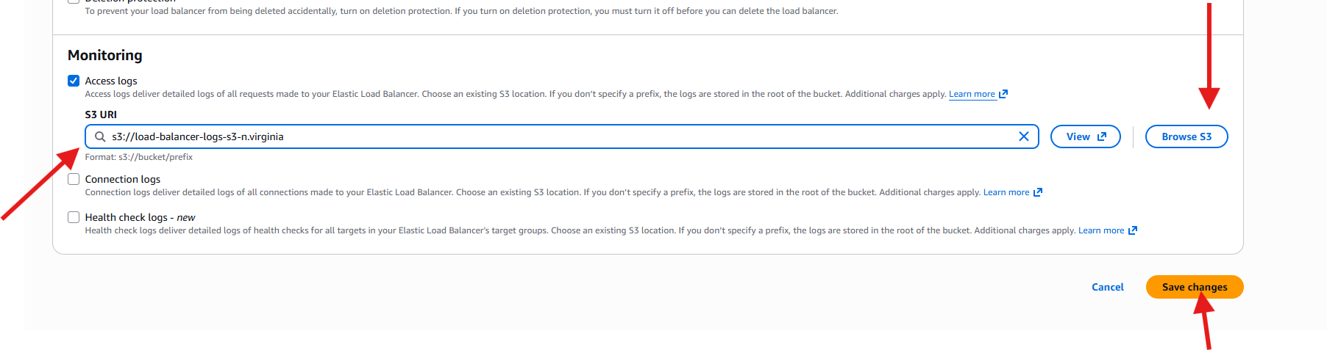

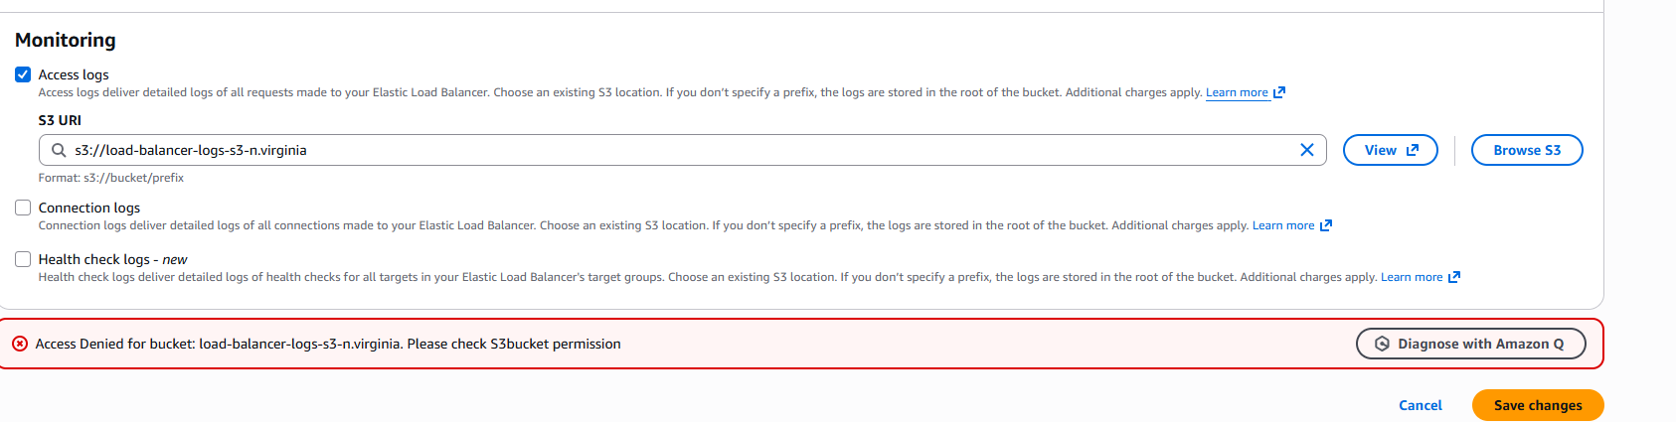

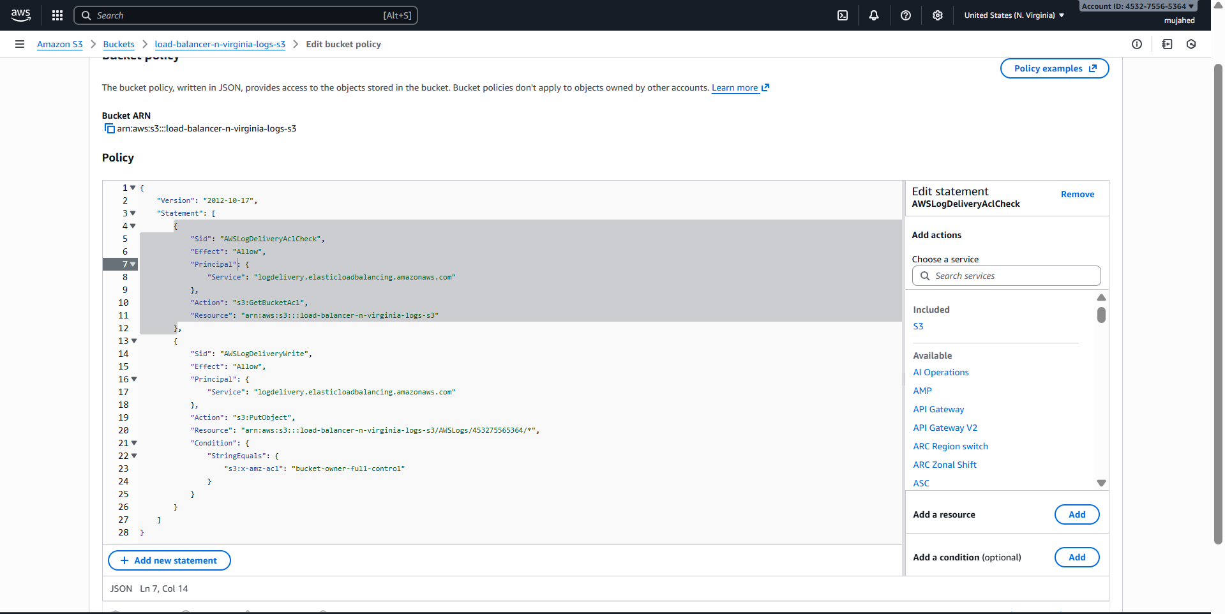

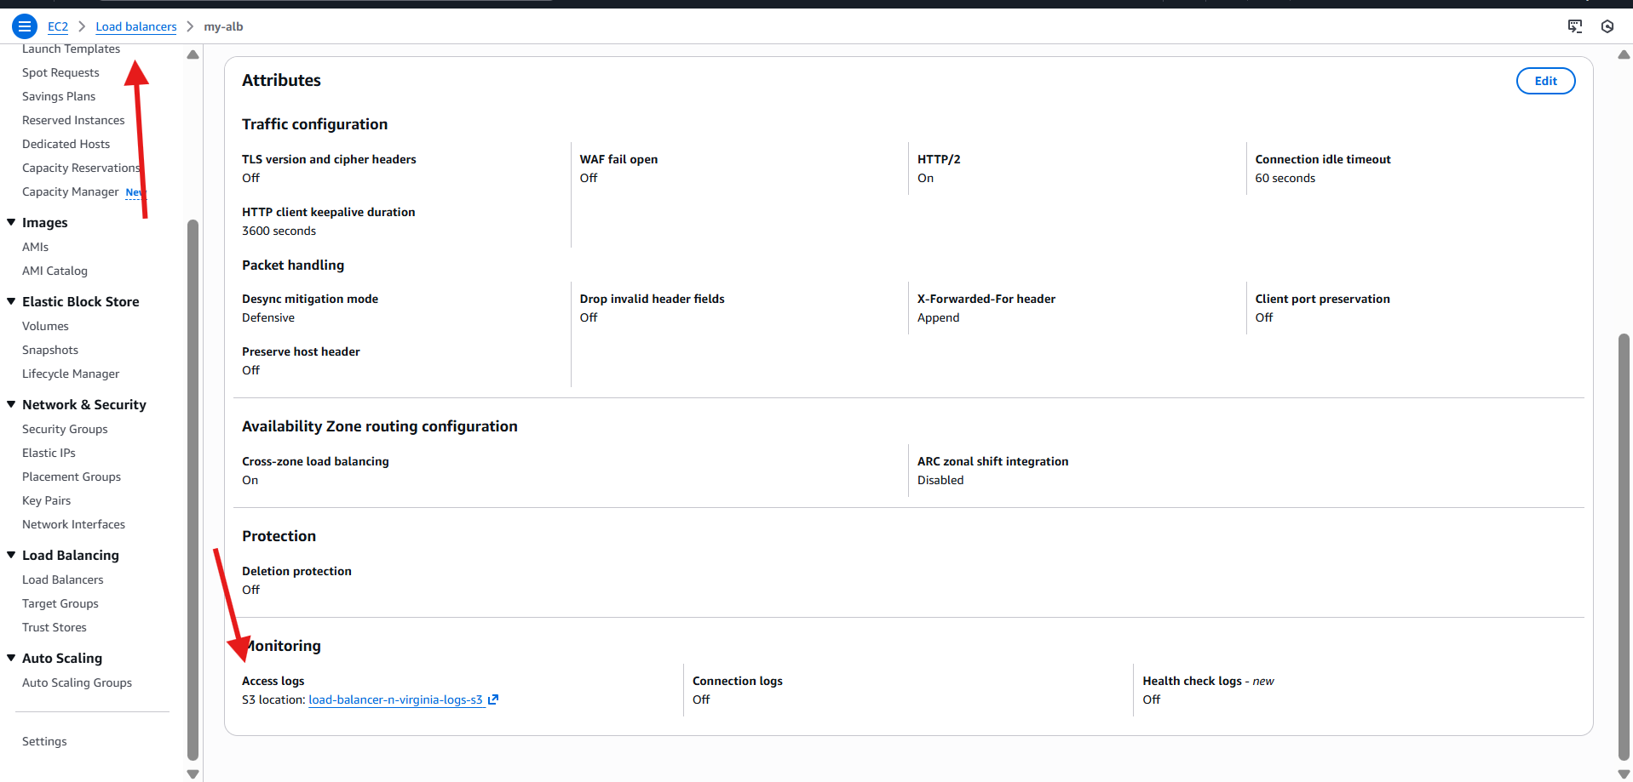

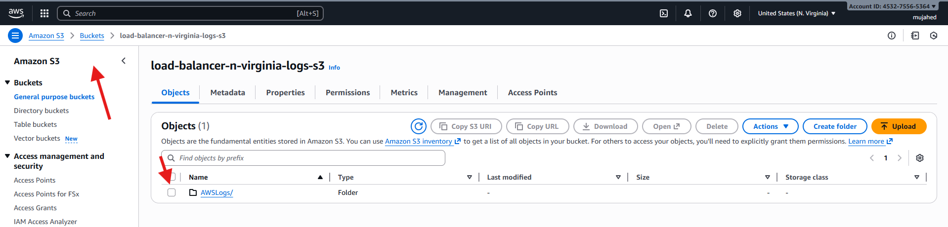

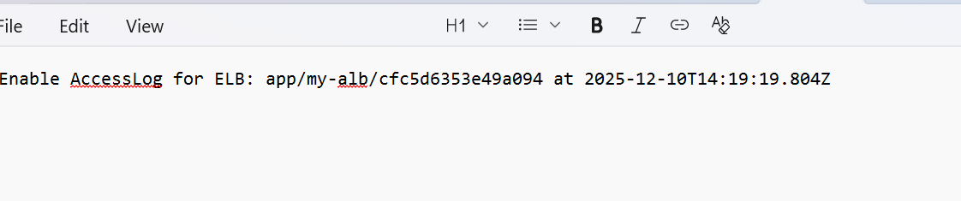

1. Store the VPC flow logs in a CloudWatch log group.

**1️⃣ Created a CloudWatch Log Group**

* Service: **CloudWatch → Log Management → Create log group**
* Log group name entered:

vpc/flowlogs

* Retention: **Never expire**
* Log class: **Standard**

➡ CloudWatch log group created successfully

**2️⃣ Created Flow Logs for VPC**

* Service: **VPC → Your VPCs → n.virginia-vpc → Create flow log**
* Settings configured:

| **Parameter** | **Value** |
| --- | --- |
| Filter | All (Accept, Reject, All traffic) |
| Max aggregation interval | 10 minutes |
| Destination | CloudWatch Logs |
| Log group | vpc/flowlogs |
| IAM Role | VPCFlowLogs-CloudWatchRole-* auto-created |

Assigned IAM role for CloudWatch  
Destination correctly configured

**3️⃣ Flow Logs Successfully Created**

* State: **Active**
* Destination Type: **cloud-watch-logs**
* Log Group Link: vpc/flowlogs

**4️⃣ Verified Logs in CloudWatch**

* Navigated to:  
  **CloudWatch → vpc/flowlogs**
* Log stream created and visible
  + Incoming network events will now be recorded here

Flow logs may take **2–5 minutes** to show new entries as traffic occurs through EC2 instances.

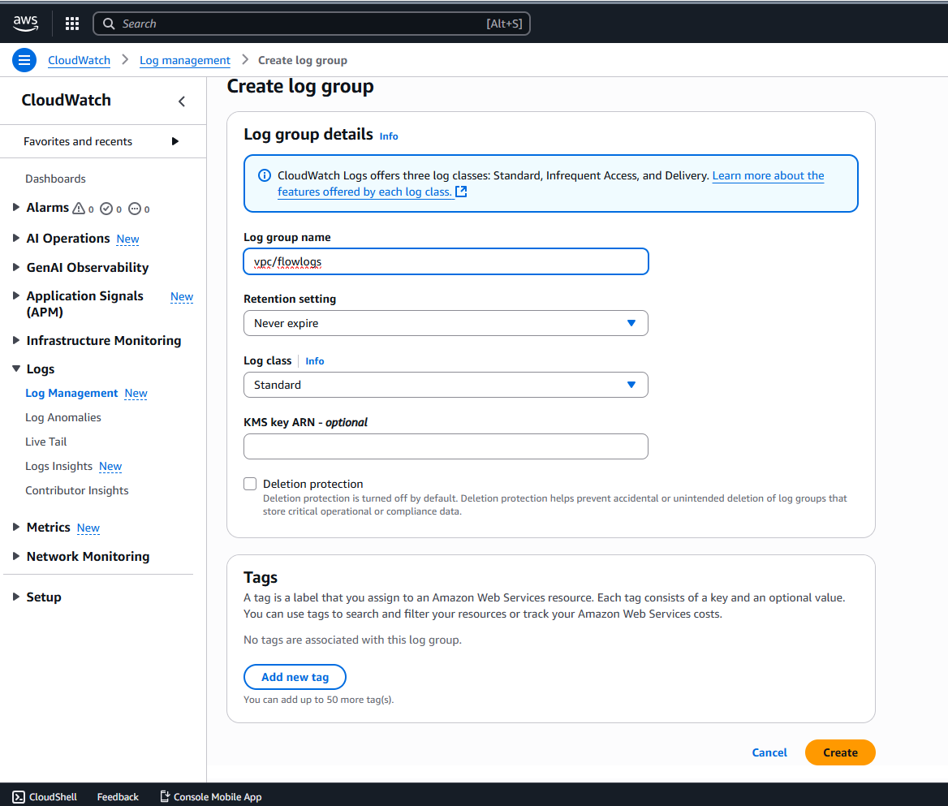

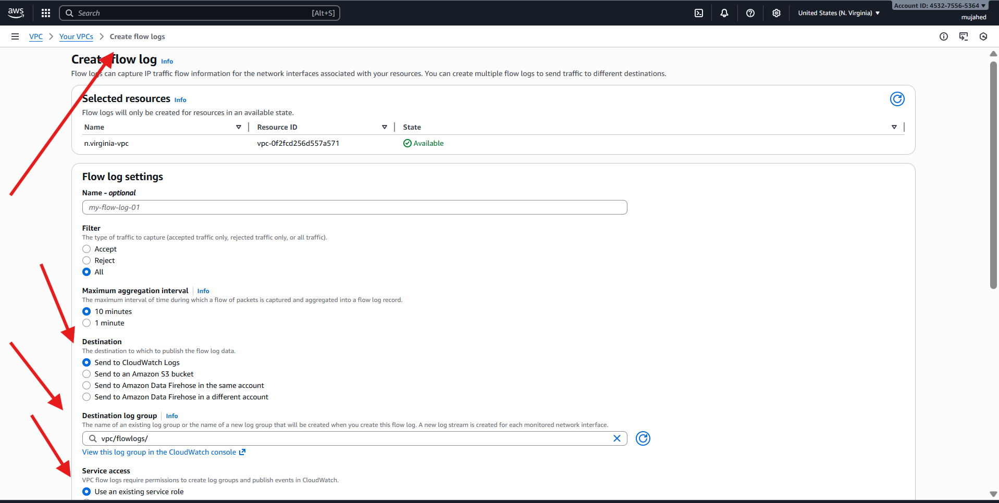

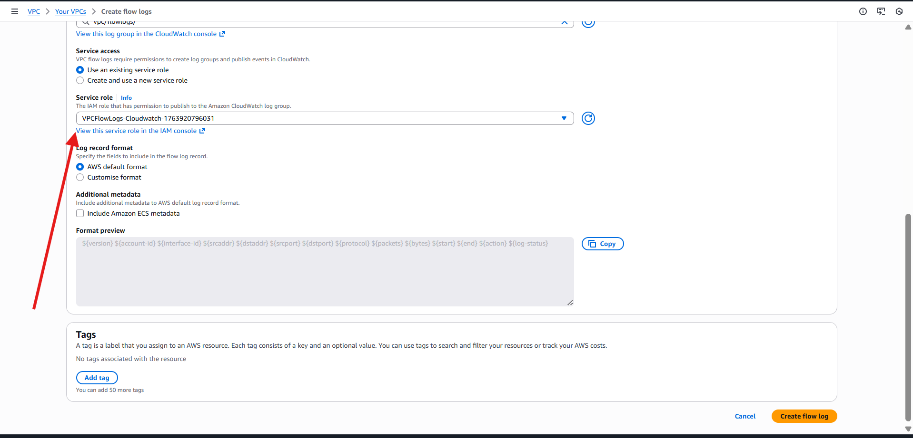

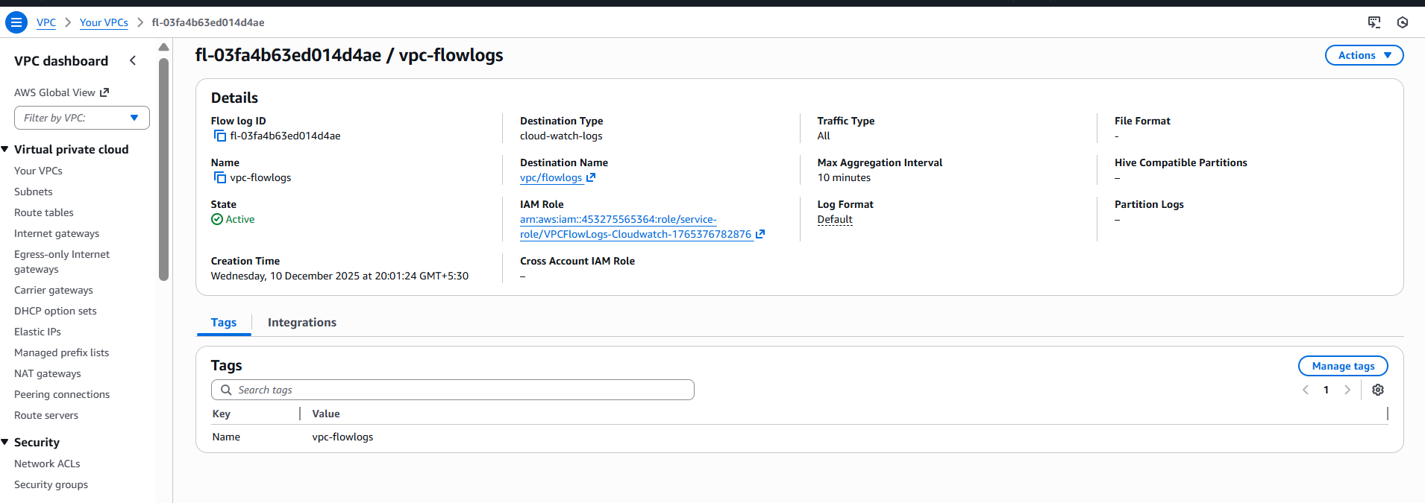

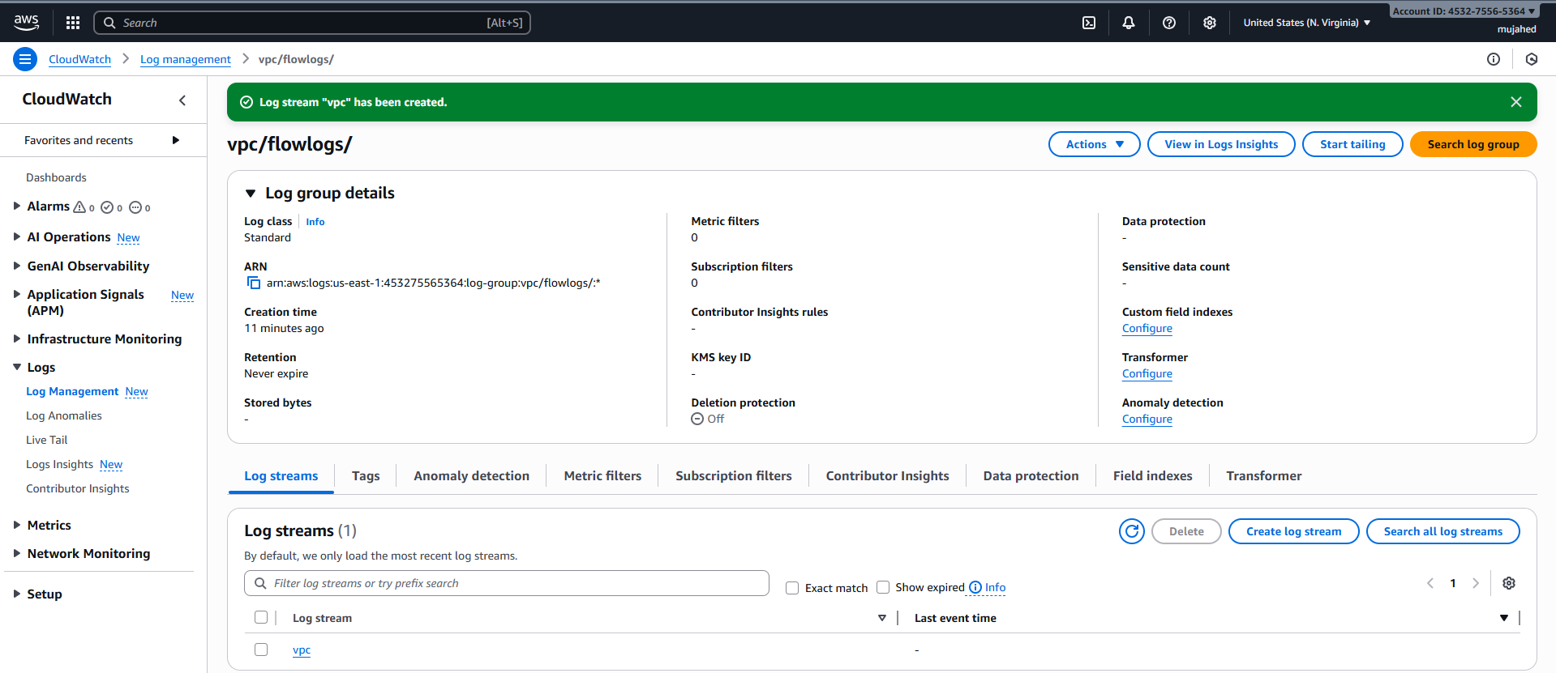

1. Create monitoring dashboards to monitor CPU utilization and to monitor the Apache service.

**1️⃣ Created a CloudWatch Dashboard**

* Navigated to **CloudWatch → Dashboards**
* Clicked **Create Dashboard**
* Named dashboard: cpu-utilization
* Selected widget: **Add a first widget**

**2️⃣ Added CPU Utilization Metric to Dashboard**

* Clicked **Add metric graph**
* Selected Region: **N. Virginia**
* Chose **EC2** as the metric category
* Selected **CPUUtilization** metric
* Metric graph displayed CPU usage ∼ **0.3%**

Dashboard now shows live CPU usage of the EC2 instance.

**3️⃣ Logged into Public EC2 Instance to Enable HTTPD Monitoring**

* Connected using SSH + Key Pair
* Checked Apache Web Server status
* Created a script to send Apache health status to CloudWatch:

Script: /root/scripts/check-httpd.sh

#!/bin/bash

METRIC_NAME="ApacheStatus"

NAMESPACE="Custom/Apache"

STATUS=0

if pgrep httpd > /dev/null

then

STATUS=1

fi

/usr/bin/aws cloudwatch put-metric-data \

--metric-name "$METRIC_NAME" \

--namespace "$NAMESPACE" \

--value "$STATUS"

* Tested script manually → returned **Apache Status: 1**

**4️⃣ Installed Cron & Scheduled Script Execution**

* Installed cron:

yum install cronie -y

* Enabled cron job every 1 minute:

crontab -e

* * * * * /root/scripts/check-httpd.sh

Apache health metric is now pushed to CloudWatch every minute.

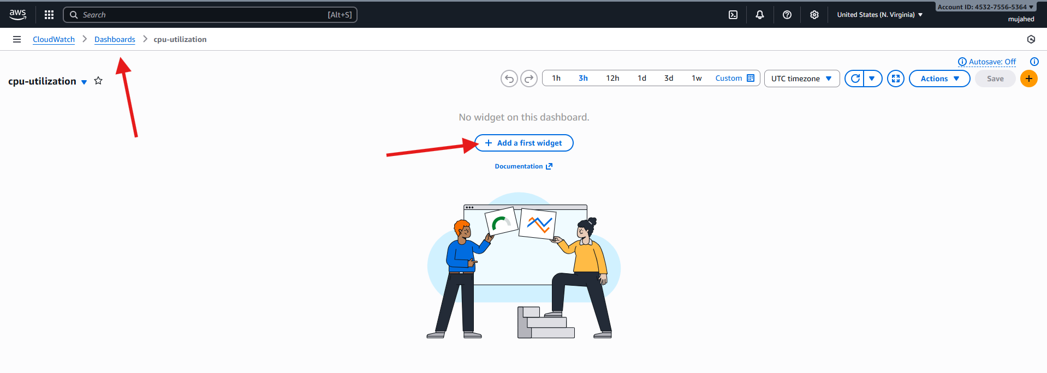

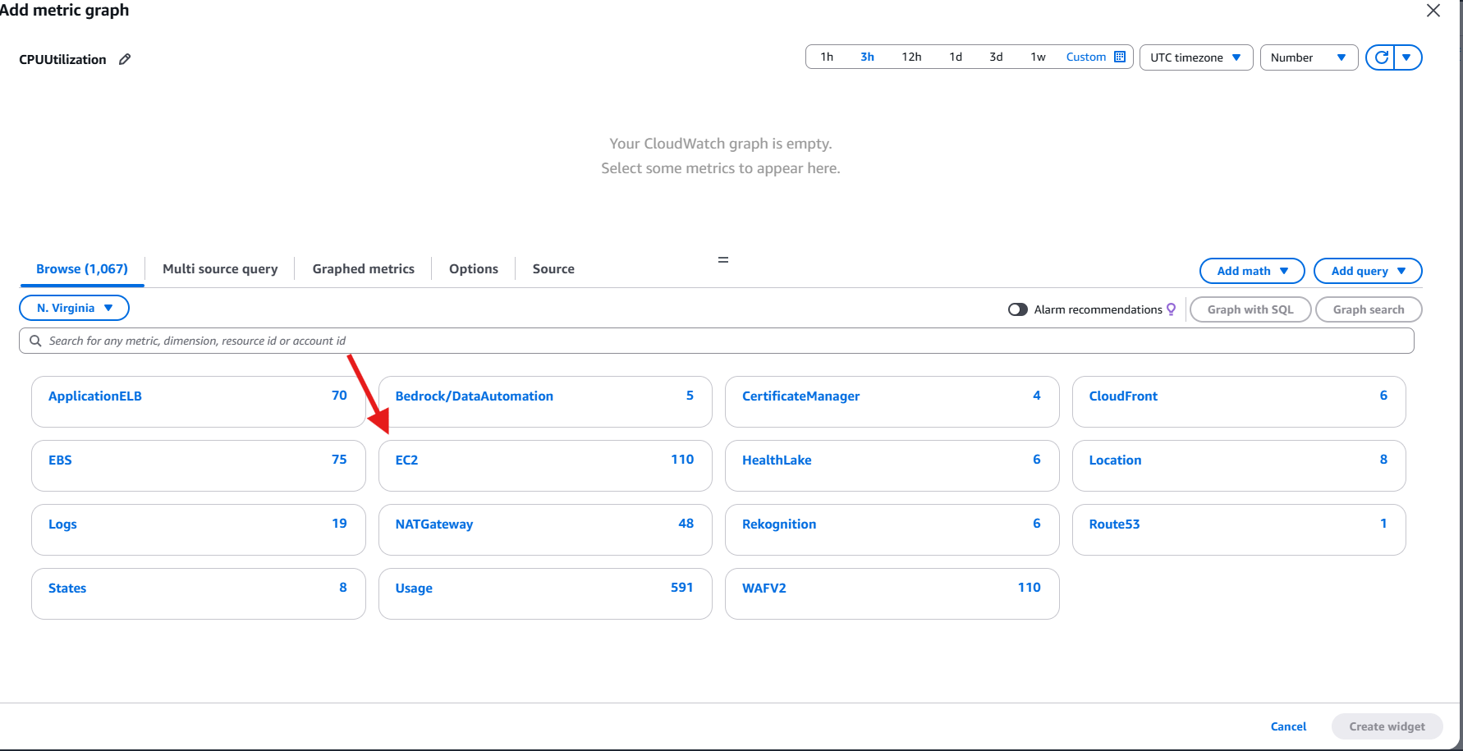

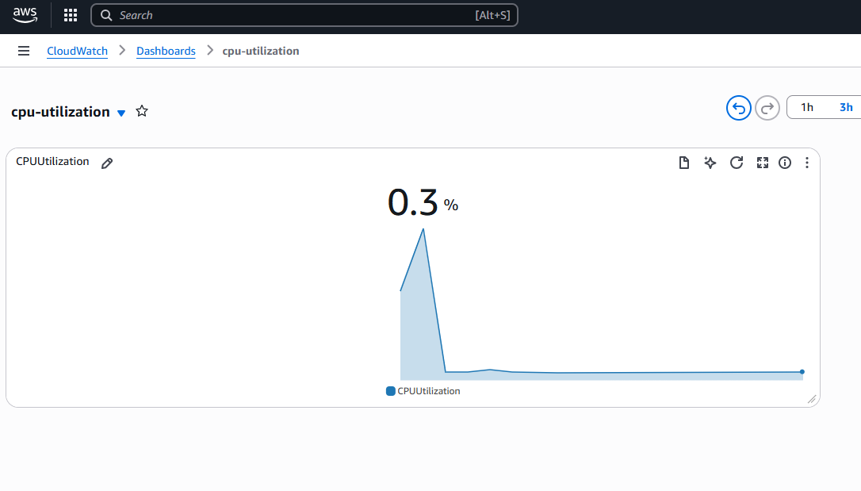

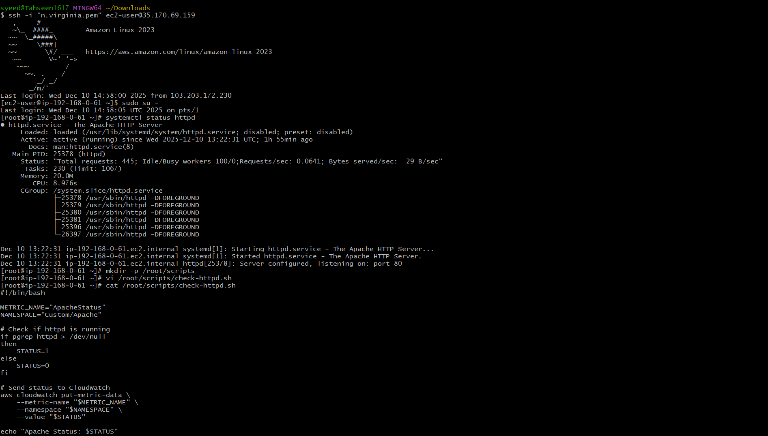

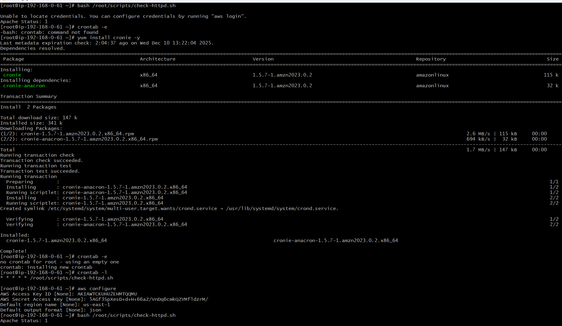



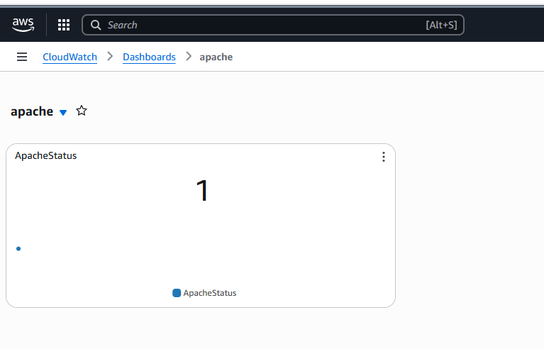

1. If CPU utilization is more than 70%, then it should trigger auto scaling and launch new instance

**1️⃣ Create a Launch Template**

Go to **EC2 → Launch Templates → Create Launch Template**  
 Enter template name → example: my-lt  
 Choose an AMI → **Amazon Linux 2023**  
 Choose instance type → t3.micro  
 Select **key pair**  
 Select **VPC + Public Subnet + Default Security Group**  
 Add **User Data** script to install Apache:

#!/bin/bash

yum update -y

yum install -y httpd

systemctl enable httpd

systemctl start httpd

echo "<h1>Autoscaling Instance</h1>" > /var/www/html/index.html

Click **Create Launch Template**

**2️⃣ Create Auto Scaling Group**

Go to: **EC2 → Auto Scaling Groups → Create ASG**  
Enter name → my-asg  
 Select Launch Template → my-lt

**3️⃣ Attach Load Balancer**

Integrate with other services → Choose:  
**Attach an existing load balancer**  
 Select **HTTP Target Group** (already created earlier)

**4️⃣ Configure Health Checks**

Enable:

* **EC2 health checks**
* **Elastic Load Balancing health checks**

Health check grace period = **300 seconds**

**5️⃣ Configure Scaling Policies**

Desired capacity → **1**  
 Minimum capacity → **1**  
 Maximum capacity → **3**

Enable **Target tracking scaling policy**

* Metric: **Average CPU Utilization**
* Target value: **70%**
* Instance Warm-up: **300 seconds**

Review → Create Auto Scaling group

**6️⃣ Generate High CPU Load (Manually)**

SSH into instance created by ASG and run:

for i in {1..4}; do yes > /dev/null & done

➡ This overloads CPU → ALB health checks fail → ASG launches a replacement instance  
➡ Auto scaling increases instance count if CPU > 70%

1. Go to **AWS Console** → Open **CloudWatch** service.
2. On the left menu, click **Metrics**.
3. Select **EC2** under the list of metric namespaces.
4. Choose the **Per-Instance Metrics** category.
5. Select **CPUUtilization** metric for your EC2 instance  
   (Instance ID like i-062...5e12 from the screenshot).
6. The metric graph will display high CPU usage (99% in your screenshot).
7. Optionally, adjust graph options:
   * Time range: 1h / 3h / 12h
   * Statistic: **Average**
   * Period: **1 second** (as shown)

This monitoring helps trigger Auto Scaling based on CPU load.

**Auto Scaling Terminating & Launching Instances**

*EC2 Instances list → multiple instances Terminated / Initializing / Running*

This shows the Auto Scaling Group performing actions due to **CPU Spike**.

1. CPU utilization exceeded the defined **Target Tracking Policy** value (70%).
2. Auto Scaling detected high load.
3. **Scale-out activity triggered**:
   * A new EC2 instance launched (Initializing state).
4. When load dropped back below the threshold:
   * Older or unhealthy EC2 instances were **Terminated** automatically.
5. Auto Scaling maintains **Desired capacity** and **Load balancing** to Target Group.

